In this Issue
Editorial | 1
Forthcoming Events | 2
Recent Events | 2
SLOG Orchard Update | 4
Plagues & Pestilence: Biennial Bearing | 4
Heritage Apple Variety Review: Isaac Newton’s Tree | 5
Making Cider Vinegar | 5
Poetry Corner – Brian Fereday | 6
Fruit Focus : Hybrid Berries | 7
Grafting to Order | 8
SLOG Shop | 8
SLOG Discount at Suppliers | 8

Editorial
No apologies for starting with the weather – we’ve had too much of it recently. December at over 23" was the wettest month for years and January then continued to dump more rain on already saturated ground. Since storm Desmond flooded Kendal and many other parts of Cumbria, storms Eva, Frank, Gertrude and Henry successively swept in bringing our Dec+Jan rainfall up to 32" – more than the annual rainfall for most parts of England in just two months. What does this mean for the health of our fruit trees? Well, curiously, even this biblical amount of rain is not the biggest hazard because potentially the greater risk is the temperature. 2015 was the warmest year on record but more significantly, we have not had a real winter chill unless you count that one weekend in mid-January when we had a little snow and frost. In other words, our trees have not had a proper winter dormancy, they have continued to metabolise and waste their energy which means that the pollen may be weak in spring, which if cold, may lead to poor fruit set. The chart below shows rainfall in inches (vertical axis) by month (horizontal axis) recorded last year in Kendal. 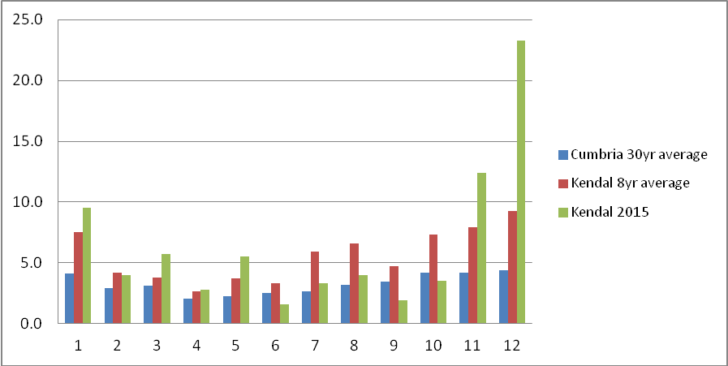 The first five months rainfall was 25% above the 8yr average. Then, although it seemed like a wet summer, the June to September rainfall was almost half of the 8yr average. But the winter storms which started in November and brought repeated flooding in December combined to make up 46% of the annual total of 77.5". This annual total was 15% above the 8yr average, and the highest in the last eight years. The other consequence of a mild winter is that stored fruit may deteriorate quicker than normal, so check your stored fruit and throw out anything developing storage rots. With the daylength increasing, preparations for the new season need to be made. February is a good time to feed your trees by applying well-rotted garden compost to provide nitrogen and act as a soil conditioner; and wood-ash from a logburner or bonfire to provide potassium. Alternatively a dressing of blood, fish & bone will provide the same nutrients in a slow release form. The coming season could be early, so winter pruning should be completed as soon as possible, and not later than end of March. Meanwhile, give your gooseberries and blackcurrants a good feed this spring in order to maximise fruit size for entry into the biggest gooseberry & biggest strig of blackcurrants competition at the AGM (see foot of page 2).

FORTHCOMING EVENTS

For the most up-to-date information look in: http://www.slorchards.co.uk/SLOGevents.html

Saturday 5th March 2016 1.30–4.30pm SLOG Grafting Workshop, Growing Well, Sizergh LA8 8AE Graft your own apple trees using M9, M26, MM106 & MM111 rootstocks at £2.50 each from a wide range of scion wood varieties. Led by Phil with advice from other experienced members. Bring your own Stanley knife (a few will be provided) and gardening gloves for protection. Wear suitable footwear as the path to the yurts may be muddy. Directions: From M6 jnctn 36 go 4 miles on A591 towards Kendal, then A590 Barrow, then shortly on right follow brown signs for Sizergh Castle, then Low Sizergh Barn. From Kendal go 3½ miles south on the A591 then just before the A590 interchange turn left into the car park at Low Sizergh Barn Farm Shop and Tearooms. Park at the far end of the car park and walk over the fields past the chicken house to the yurts.
Saturday 9th April 2015 (provisional), Damson Day at Low Farm, Lyth Valley LA8 8DJ The first local show of the year and always a well attended, friendly occasion. SLOG stand will be there. More detail (eventually) on WDA website http://www.lythdamsons.org.uk/index.html Directions: Take A590 to Gilpin Bridge, then A5074 direction Bowness for 2 miles to Low Farm. Follow signs to car park.
Saturday & Sunday June 4th & 5th
CountryFest, at the Westmorland Showground, Crooklands, Kendal.
The SLOG stand will be in the Countryside tent. For more information go to: http://www.westmorlandshow.co.uk/index.html
Summer Orchard Visit, date to be advised, either in June or July
Saturday 25th June – Summer Fete at Sizergh Castle Details to follow on SLOG website in due course and in next Newsletter.
Tuesday July 26th 7.30pm – SLOG AGM at Levens Institute This is your chance to air your views on what SLOG should or should not be doing and help shape our future strategy. Followed by a gooseberry and blackcurrant show (biggest berry & strig of currants).

RECENT EVENTS

WINTER TALK Tuesday 24th November, Levens Institute
A record turnout of almost forty members came to listen to Anthony Fitzherbert’s talk on Afghanistan. Computer problems forced us to rearrange the running order so Andy started with a demonstration of bush fruit pruning. 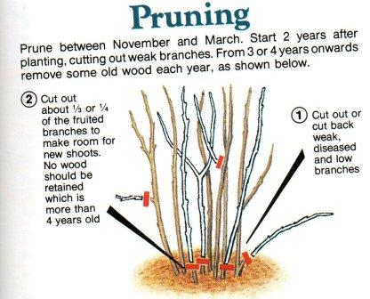
Blackcurrants (above) are pruned differently from gooseberries, red & whitecurrants (below):
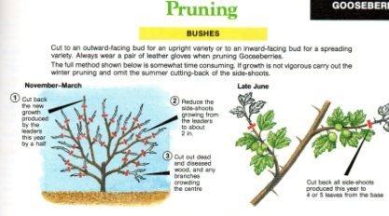
We then raffled the mystery pear tree and enjoyed hot drinks with Adele’s chocolate cake by which time Ken came to the rescue with his back-up laptop which enabled Anthony to present his striking pictures of Afghanistan. This showed that despite everything that has happened in the recent history of this unfortunate country, it still has a remarkable natural beauty and a resilient population, who prompted by Anthony and his colleagues, have made a success of growing and exporting a wide range of top fruits including apples, almonds, apricots, walnuts etc. Our thanks to Anthony for showing a more positive side to this country than that which is presented by the media. The following is taken from the website of the charity “Afghanaid” of which Anthony is a trustee: “Anthony is a leading authority on Afghanistan’s agricultural sector. For the last 45 years, he has worked on rural development, livestock husbandry and natural resource management in Iran, Turkey, Afghanistan and Central Asia. In Afghanistan, his work has involved moving post-conflict emergency assistance into longer term development and production. Anthony speaks fluent Dari and has travelled and worked in almost every part of the country. In 2011, he was awarded the OBE for his work with agriculture and farmers in Afghanistan.” www.afghanaid.org.uk/

WINTER PRUNING WORKING PARTY Wednesday 20th January Holeslack Orchard
Heather from the National Trust at Sizergh Castle asked if SLOG would help them with a winter pruning session at one of the tenanted orchards on the estate. Brian Fereday had planted the orchard about ten years ago and it looked like it had never been pruned for years. 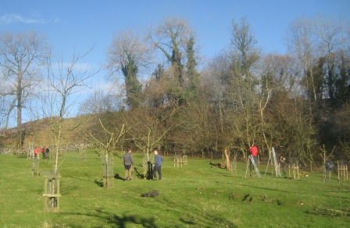The trees are on vigorous rootstocks and had made good, perhaps too good, growth. Most trees needed their centre leader removed and the centre opening up into something like the classical goblet shape. Canker was a problem on many trees, so a fair bit of cutting out diseased wood was done. By the time we had finished, the trees looked as if they had been to the barber’s for a short back & sides (or whatever the current hairdressing fashion is called!). 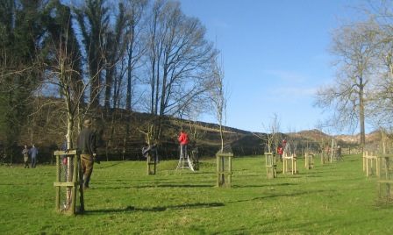After lunch at the café, we moved to an adjacent orchard where Brian had planted some new trees among some very old trees, and gave these similar treatment. The second orchard had a few old & young pear trees which were very healthy and had no canker, just a little scab. 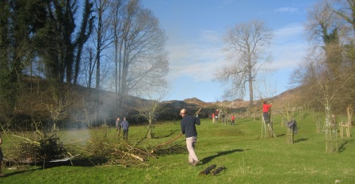Meanwhile, one of the NT volunteers had a good bonfire going to burn all the prunings. The weather was ideal, being clear and dry, so that in full sunshine on a south facing slope we hardly noticed the cold (just 5°C). With about ten from SLOG and a similar number of NT staff & volunteers, the work was done in good time despite most of it being ladder work. Heather was very grateful for our help as per her email:
“Hello All, I just wanted to say a huge thank you to everyone who pitched in at Holeslack Orchard today - an incredible amount of work was achieved in a short space of time, helped by beautiful weather and a great fire. I'm looking forward to returning to the Orchard in the Summer to see the results of our efforts! Please pass on my thanks to those I don't have email addresses for, especially those who left at lunchtime as I didn't get a chance to thank them personally. Best wishes, Heather Birkett”

WINTER PRUNING WORKSHOP Sunday 31st January Grange-over-Sands Community Orchard
The weather was unkind to us this time, being only 5° and drizzling. The forecast had been poor which may be why only a dozen people attended, a fraction of last year’s numbers. 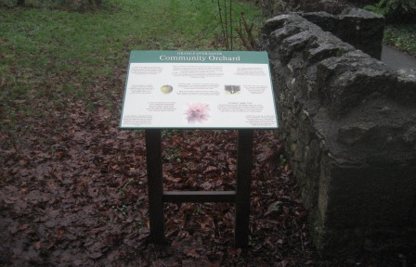
Nevertheless we reviewed the principles and practice of winter pruning and then set about pruning some of the apple trees, ably assisted by new expert member Chris Helm. As a small group we were unable to prune all the trees, but did enough so that everybody felt ready to have a go at their own trees, in better weather of course! The photo above shows the new information board which SLOG helped to finance. It is of aluminium construction in order to be vandal proof after the previous wooden framed version had been vandalised.

SLOG ORCHARD UPDATE
The deluge of 5th December caused the underground stream to rise above the culvert and the excess to flow overground from the southwest corner to the northeast corner, thereby scattering stones over its path. However, the value of the grass alleys was demonstrated in that they prevented any significant erosion. 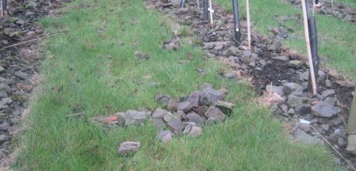Stones & debris scoured out of the rows onto the grass alleys We came off relatively unscathed compared to a couple of neighbouring allotments which had glasshouses bowled over.
The SLOG orchard is on the Underley Road Allottments, situated between Underley Road & Hallgarth Circle just east of Windermere Road.
The south entrance is off Underley Road from where a narrow green lane leads to a gate on your left which opens directly into the orchard.

“PLAGUES & PESTILENCE” BIENNIAL BEARING
Some apple trees bear heavily one year and sparsely the next. This is called biennial bearing. A very heavy crop one year may prevent adequate bud formation for the following year.
Varieties which are especially prone include: Blenheim Orange, Bramley, Claygate Permain, Tom Putt, Devonshire Quarrenden, Early Victoria, Wyken Pippin, Ellison's Orange, Laxton's Superb, Laxton's Fortune, Rev. W. Wilks, Elstar, Tydeman's Late Orange.
Preventing biennial bearing on some trees is difficult. There's also the problem that a group of trees will often become biennial together.
The remedy, which sometimes works, is to thin. Authorities differ as to how and when. "Early, heavy thinning during the large-yield year. Thin fruit to between 9" apart and 5" apart depending on size, within 30 days of the petals coming off". "Do it early, soon after fruit-set. Don't wait for the June Drop. Thin fruit to between 3" and 5" apart". "Thin leaving a single apple every 6 to 8 inches - this will double the percentage of large fruit".
Some growers suggest rubbing out some of the fruit buds in the heavy-cropping year.
Joan Morgan and Alison Richards (who wrote "The Book of Apples") recommend thinning when the apples are just under half an inch across. Eaters to 4 - 6 inches apart; cookers a bit further apart. "Pinch out the fruitlets as soon as possible after the fruit has set." Nigel Deacon says: "Some trees go biennial if they're not fed enough. Some go biennial no matter what you do. Trees I've found especially prone are some of the heavy - yielders: Allen's Everlasting, Claygate Pearmain, D'Arcy Spice, Golden Hornet (crab), George's Red, Red Devil, Devonshire Quarrenden. "
With acknowledgements to Nigel Deacon’s Diversity website and The Royal Horticultural Society

HERITAGE APPLE VARIETY REVIEW: ISAAC NEWTON’S APPLE (AGAIN)

Eagle-eyed readers may notice that this variety was previously reviewed only last summer. The reason for a repeat review is that the author’s curiosity led him to visit Woolsthorpe Manor where Newton was born in 1642. The site is owned by the National Trust. An information board at the orchard gate claims that the original tree, under which Newton postulated his law of gravity, was blown down in a storm in 1820, but that the broken trunk rooted and regrew, resulting in the old tree which stands today. 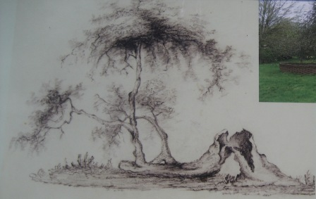Sketch of the fallen tree regrowing © The Royal Society It is difficult to imagine any broken trunk rerooting when you consider that most apple varieties (this one included) will not root from cuttings, which is why we graft or bud them onto rootstocks. Joan Morgan’s version of the story (from her “New Book of Apples”) is that the original tree died in 1814 – already a good age since it must have been around 200yrs old. 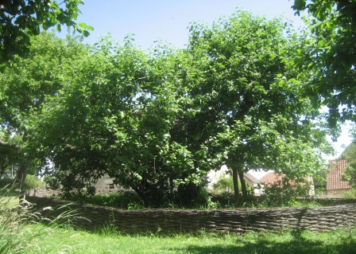 The tree which stands today (pictured above) was propagated from the original and is likewise now about 200yrs old. Who do you believe: The National Trust or Joan Morgan? Why not visit Woolsthorpe Manor and decide for yourself? If you are travelling along the A1 in Lincolnshire, it is a good place to break your journey for a tea, coffee or snack in their “Newton’s Barn Coffee Shop” – much better than a motorway service station! It is located only a couple of miles off the A1 at the junction with B676 (entry free for NT members). Just follow the brown signs or put NG33 5PD into your Satnav.
MAKING CIDER VINEGAR
Making cider vinegar is easy. In the same way that apple juice, left to its own devices, will start to ferment into cider using the natural yeasts present on apples, there is another natural process that will turn the resulting alcohol into acetic acid to make vinegar.

Apple juice > Cider > Cider vinegar

Just as we manage the process to ensure a successful fermentation, we need to manage the step to make vinegar, but it is even easier as the process requires oxygen, so you don’t need sealed vessels.
After fermentation has finished, all the sugars in the apple juice have been converted into alcohol. The next process makes use of Acetobacter, another natural microbe, to convert the alcohol into acetic acid. However, Acetobacter is lethal to good cider-making, so make sure you keep the two processes and equipment separate.
If you put your finished cider into a wide mouthed vessel and cover it with muslin, it will turn to vinegar with the natural Acetobacter in the air. This can take between a couple of months and a couple of years, depending on
temperature (ideally 30ºC, same as cider) and air circulation, but you can speed it up with a little bit of management.
Make sure you put your muslin covered vessel where there is plenty of air movement. I’ve been keeping mine in old glass sweet jars at the corner of the stairs where the air circulates several times a day as we pass by. If you put it somewhere out of the way, under the stairs for example, there is very little air circulation so it will be very slow.
You can add the Acetobacter yourself. Vinegar mother is a white layer that appears on top of your vinegar during the process. You don¹t need much so it can be propagated from someone who already makes vinegar and once you have it, it is easy to keep alive. You can also sometimes buy ‘live’ cider vinegar (ie with the mother) to add, from some health-food shops. Once you have your vinegar mother you can also use any left over half-bottles of wine to make wine vinegar although, with all that cider, you probably don’t drink much wine!
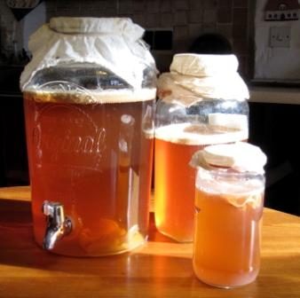Commercial systems bubble air through the cider to speed up the process and it would be fairly easy to do with fish-tank apparatus but I don’t bother. Instead, when the white ‘mother’ forms on the surface, I give it a little swirl as I imagine this layer of cellulose reduces the oxygen reaching the cider. I haven’t read that you need to do this but I think it makes sense. The mother sinks when it is disturbed giving a new liquid surface in direct contact with the air.
The resulting delicious vinegar is ideal for salad dressings and drinking for your health, and it will keep indefinitely in sealed bottles, often forming a layer of ‘mother’ at the top. However, as there is a direct link between the alcohol content of the cider (normally about 5-6%) and the acid content of your vinegar, I find that it isn’t strong enough for making pickles and chutneys. But with a minor additional process, you can make vinegar as strong as you like.
You just need to make your cider stronger BEFORE you start the vinegar process. There are two easy ways you can do this. The easiest is to add sugar to your cider while it is fermenting. The disadvantage of this method is it is not easy to calculate how much sugar to add to get the alcohol (and therefore acidity) you want to end up with. The advantage is that you will end up with much greater quantities of strong vinegar so this is how it is done commercially.
I prefer to wait until cider fermentation has finished and then freeze-distill it. To do this, leave a tupperware container of finished cider in the freezer overnight. As the freezing point of alcohol is -114ºC, only the water in the cider will freeze and you can just pour it through a sieve to remove the water (make sure you collect the liquid in a container under the sieve, that’s the bit you want). For making chutneys, I aim to roughly halve the volume of liquid so the alcohol content (and final acidity of the vinegar) will be doubled at around 10%. This is achieved with just one freeze but by freezing and removing the ice several times you could make it much stronger.
The traditional set-up for vinegar-making is known as the Orleans or barrel process and consists of a barrel laid on its side, three-quarters full of liquid and with just a muslin cover. The alcohol converts to vinegar at about 1% per week so cider with an alcohol of 6% can give a vinegar of 6% acetic acid within a couple of months depending on conditions. Two-thirds of the vinegar is then drawn off, fresh cider is added, and the cycle is repeated. My apparatus for this uses an 8 litre glass Kilner jar with a tap at the bottom so the sediment doesn’t get stirred up when drawing off the finished vinegar.
I can let anyone have vinegar mother and I highly recommend having a try as the end product is really good and you can’t really go wrong.
by Adam Rubinstein
POETRY CORNER
Infatuation © by Brian Fereday, 2013

Beautiful chaos here,
I love you, you Westmorland orchards.
Trees there,
Form full and formless
Damson, apple, plum and pear.
Touched by senescence
Or the bright flush of youth.
Nameless varieties
Favourite varieties.
Sources of fruit and firewood.
Where sheep may safely graze,
Amongst blossom as white as lambswool.
Goldfinch nests on swaying branches
Crows on sweetest fruit.
Hedges, walls and fences
As diverse as the people.
From generations past and present
Respect for human endeavour.
Working the land.
Asking of us
The unanswerable question.
What to do with that big tree
That one “that never has anything on it”.
Let her remain.

Brian is a founder member of SLOG and was our first Membership Secretary. He was born in Levens and started his career as a woodland research scientific assistant, before going on to work for 38 years as a forester and estate manager for The National Trust at Sizergh. Conservation and nature have always played a huge part in his life, in fact he would go as far as describing them as his raison d'etre. In 2010 Brian took early retirement at 60 and sadly fell victim to a terribly debilitating condition; Motor Neurone Disease robbed him of many faculties, his power of speech being one of them. Contrary to this, in Homeground, his poetic voice resonates stronger than ever.
Brian's poems stem from a lifetime of observing and working on the land. From the four-line 'Bliss' to the four page 'The Burden', he tells it exactly as he sees, feels it - and how it was.
"The poems are written from my observations and realisations. I hope the poems and illustrations inspire others to go out and make links with their landscapes, plants, trees and animals, human or fur and feather."
Homeground is beautifully illustrated by Brian's wife, Fiona Clucas, one of the region's best known artists and a founding member of Kendal's Green Door arts co-operative. Her inspiration also comes from a love of the area's many varied habitats - its wildlife, flora, the elements and their effects on the landscape.
Fiona captures nature in mixed media, while Brian paints vivid pictures with words. This exceptional book is available at Low Sizergh Farm Shop and Beetham Nursery, price £15. Narrative courtesy of Beetham Nursery.
FRUIT FOCUS: HYBRID BERRIES
The term “Hybrid Berries” applies to a group of cane fruits of the genus Rubus, most of which have been created by crossing blackberries with raspberries. Blackberries are a genetically diverse group of species, with most crosses derived from the Pacific blackberry Rubus ursinus (also known as the dewberry) and some from the European blackberry Rubus fruticosus. The resultant hybrids have subsequently been crossed with each other as shown in the diagram below (courtesy Royal Horticultural Society): 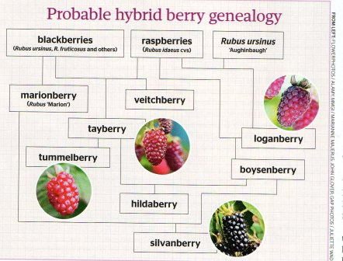The oldest of the above hybrid berries is the Loganberry which arose as a spontaneous hybrid in a Californian garden in 1883. Its fruit is large, dark red and sharper tasting than raspberry. Its vitamin C content is so high that the British Navy preferred it to limes for the prevention of scurvy in the early 20thC. It is claimed to make the best jams & preserves of any temperate fruit. The Boysenberry dates from 1920 and tastes more like a blackberry but is less hardy and may not be suitable for our region. Tayberry & Tummelberry were raised by the Scottish Crop Research Institute near Dundee in a 1979 breeding programme. Both are claimed to be sweeter than Loganberry. Most hybrid berries have multiple cultivars, including thornless varieties. They are easy to grow, being floricanes which crop on two year old wood so pruning is the same as for blackberries or floricane raspberries, in other words cut out old canes after harvest and tie in one year old canes as replacements. They are best trained on wires or against a wall or fence and need at least 6’ of space, but are also good for filling unwanted corners and will tolerate poor land. SLOG had a Tayberry and thornless blackberry donated; these are growing against the east wall of the orchard.
GRAFTING TO ORDER
The SLOG grafting to order service is still available but only up to early March. If you want a particular variety on a particular rootstock, it can, subject to availability, be grafted for you. Adele Jones is the co-ordinator for this service. Price is unchanged at £15 per tree, buyer collects. Call Adele on 015395 52102 for enquiries & orders.
SLOG SHOP
1. SLOG has a range of 1yr old container grown maiden apple trees for sale at £13.50 each, comprising traditional varieties suitable for our Northern climate on MM106 rootstocks. Visit http://www.slorchards.co.uk/TreesForSale.html to see the list and for guidance on purchase and collection.
2. Wells & Winter labels are the most cost-effective permanent solution for recording tree variety identity. They are rigid black plastic labels measuring 2 x 3½” (5x9cm), giving a permanent and very visible result. 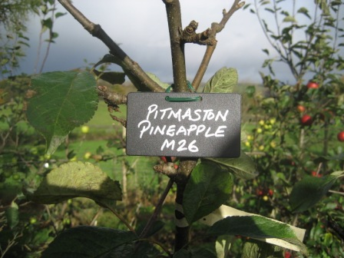They are available at 15p each along with a deposit for the silver pen (if taken away)

3. Recipe books: sold out but a reprint is under consideration.

4. Apple Notelet cards £2 per pack of 5 different cards each featuring a different apple variety. 5. The Apples & Orchards of Cumbria: Lavishly illustrated with over 100 full colour photos describing the twenty or so Cumbrian apple varieties and the fifteen orchards open to the public. Judged runner-up in the “Landscape & Tradition” category of the Lakeland Book of the Year Awards, 2014. £9
All the above items are available at SLOG events such as Workshops, Shows and Apple Days.
SLOG Discount at Suppliers: Rogers & Beetham Nursery
SLOG has negotiated a 10% discount at Rogers of Pickering for SLOG members. When you place an order for any kind of fruit: trees, bushes, etc., quote your SLOG membership number and Rogers will apply 10% discount to your total bill. For e-mail orders go to: http://www.rvroger.co.uk/?linksource=frontpage
We also have a 5% discount at Beetham Nursery applicable to all items (except in the café). Just show your SLOG membership card at the checkout. www.beethamnurseries.co.uk/
TAILPIECE
“The Apple of Your Eye” is a quarterly publication, the next one being the summer issue due mid-May. Contributing articles, preferably in word.doc, are welcome, along with photos where possible, by the end of April 2016 to: newsletter@slorchards.co.uk

Disclaimer - The information in this newsletter is provided on the understanding that SLOG makes no warranties, either expressed or implied, concerning the accuracy, completeness, reliability, or suitability of the information. Nor does SLOG warrant that the use of this information is free of any claims of copyright infringement.

The opinions expressed in this publication do not
necessarily represent the views of SLOG.
© 2016 South Lakeland Orchard Group

