In this Issue
Editorial | 1
Forthcoming Events | 2
Recent Events | 2
SLOG Orchard Update | 3
Plagues & Pestilence: Watercore | 3
2020 Season Review | 4
New Apple Variety: Flanders Pink | 6
Hilary’s Apple Stories | 6
Rootstock Orders | 8
Grafting to Order | 8
SLOG Shop | 8
SLOG Discount at Suppliers | 8
Editorial

2020 is a challenging year for all of us and it has resulted in the longest suspension of SLOG activities in our 13 year history – we went for 21 weeks with no SLOG events of any kind from the mid-March SLOG orchard working party until resuming action with the recent Summer Pruning workshop. Government guidance effectively limits us to outdoor events only so the SLOG AGM has been postponed and will either take place at our November winter meeting if regulations are to be relaxed by then, or else it will be done electronically.

The hiring process for the popular Spiedel mill & Hydropress kit will be different this year. Sizergh Castle National Trust have advised us that they cannot handle the process this season because they are short-staffed. SLOG member Mike Gibson has kindly volunteered to host the kit at Tarnside Farm, Crosthwaite LA8 8BU. If you wish to hire the kit, email Mike at: mgibson231@btinternet.com or phone 015395 68639 with your requested date(s). Collection and return must be made between the hours of 9.00-9.30am and 4.30-5.00pm. Please respect these hours since this is a working farm. The farm is situated 200yds up a narrow lane off the A5074 just south of the A5074 junction with Totter Bank. As you turn into the farmyard, fork right to the barn, don’t go left to the house where turning is difficult. Hire charge is unchanged at £20 per day of use. Please return the equipment clean and ready for the next person to use in order to recover your £25 deposit.

To book the large press & trailer, phone Dick Palmer on 01229 716095 or 07799 615750 or email dickrhonapalmer@gmail.com The large press hire charge is £25 per day plus £25 deposit returnable when the entire equipment and trailer is returned clean and ready for the next person to use.

We still have the hand scratter and barrel press kit which is available on a free of charge collect and return basis to local schools to encourage children to take a greater interest in local fruit and make their own juice. If you know any schools who may be interested, please let them know and advise them to email: andyjgilchrist@hotmail.co.uk
SLOG container grown trees are again available for sale at £15 each, mostly 1yr old maiden whips of local, heritage and popular varieties grafted this spring. Collection from High Newton by arrangement with Kirsten & Paul: email both kirstatjoneskins@gmail.com and ackyboy@hotmail.com

There are no plans for SLOG Committee meetings for quite a while yet.

Finally, please note that it’s time to order your rootstocks for next season – see page 8 for details.

FORTHCOMING EVENTS

For the most up-to-date information look in: https://www.slorchards.com/events

Sunday September 20th 10.00am - 3.00pm Members' Apple pressing day at Abi & Toms Halecat Garden Centre, Witherslack (this date is provisional subject to no further government guideline restrictions and will be confirmed or amended in a further email to members and posted on the website) There will be a booking system to ensure numbers do not exceed six households at any one time. The process will be slower since we will have to sterilize all fruit before pressing and ensure no cross-contamination between batches. There will be no mixed batches so ideally bring up to 40kg of apples for a single batch pressing. All welcome. Free to members, and visitors can join on the day. To book a time slot, phone Dick Palmer on 01229 716095 or 07799 615750 or email dickrhonapalmer@gmail.com Directions: Follow A590 west and take the Witherslack turning. Pass the Derby Arms and take the left turn in the village centre. Follow the brown signs for Halecat Garden Centre.
Sunday November 1st 10.00am - 3.00pm - Members' Apple pressing day at Sprint Mill, Burneside (this date is also provisional subject to no further government guideline restrictions and will be confirmed or amended in a further email to members and posted on the website) The final opportunity to bring your apples for pressing into juice. Don’t forget to bring containers for the juice and bags to carry away the spent pulp. Directions: From Burneside take road past paper mill towards A6, Immediately before bridge over River Sprint take track on left for 100yds then park on left.
Tuesday 24th November – Winter Talk 7.30pm Crook Memorial Hall (Again – provisional subject to government guideline restrictions and will be confirmed or amended in a further email to members and posted on the website) This may incorporate the AGM, details to be advised later. Directions: From Plumgarths roundabout at the north end of Kendal, take B5284 direction Bowness. Go through Crook village, past the Sun Inn, then up the hill and the Hall is on your left at the top of the hill. Satnav LA8 8LG
Other Apple Day Events: Most Third Party Apple pressings will not take place this season due to government restrictions on the limited numbers of people permitted to attend events, risk of virus transmission and also because of reduced crops due to frost damage. Specifically, the following events which SLOG normally attends or supports will NOT take place this season:
Arnside & Silverdale AONB
Apple Day at Ford Park, Ulverston
Apple Pressing at Low Farm, Lyth Valley
Apple Day at Beetham Nursery will take place on the weekend of 10/11 October but there will be no apple pressing

Apple Event at Acorn Bank, Temple Sowerby, near Penrith

Sedbergh Apple Day

RECENT EVENTS

Summer Pruning Workshop Saturday 8th August
Summer pruning is a useful means to slow the growth of over-vigorous trees. It is normal practice on restricted tree forms such as cordons, espaliers, fans & stepovers. The cordons at Growing Well are a good example as they are now almost twenty years old on MM106 rootstocks and fairly vigorous. A small but enthusiastic group of us met in warm sunny weather and after discussion about the technique, set about putting it into action. 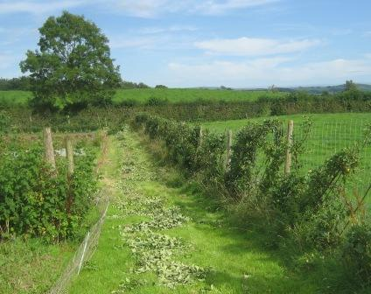We effectively gave the trees a “short back and sides” by cutting the tops back to the top wire and pruning the annual extension growth back to three buds. Sadly the trees were carrying very little crop due to the damage done by the mid-May frosts, though the Red Miller’s Seedling (early dessert) were just ripening and very tasty. In previous years we have run a budding workshop concurrently with the summer pruning but since this is an indoor activity it was judged to be unsafe given the current perceived virus transmission risk.

SLOG ORCHARD UPDATE
The frost in mid-May hit our apples very hard and it is rather sad to see so little fruit this year – not much more than 100 apples in the entire orchard. Only those varieties which flowered early and mainly cookers have carried fruit to harvest. The trees themselves are in good condition and compensating for the thin crop by putting on strong vegetative growth, so our 15th August working party summer pruned the trees back into shape. The pear crop is also disappointing with only about 30 fruit, though the trees themselves are healthy. Weed growth in the rows has again been strong, so we hand weeded all rows and filled the compost heap completely. We also weeded and pruned the roses. 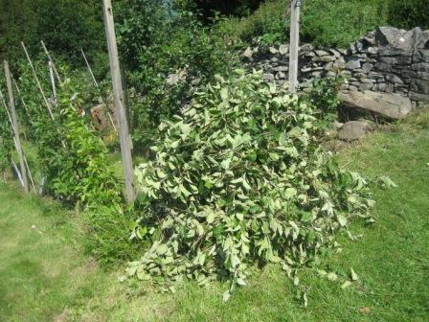 The pile of prunings after we had finished
Many thanks to George, Tonia, Debbie, John, Andy, Adam, Steve, Jacqueline, Pauline, Joanna & Bryan. The next Working Party will be in November to remove some trees shown by DNA to be non-authentic and replace them with their definitive versions, put a few new stakes in, do any tidy-up winter pruning required, remove rootstock suckers and trim back excessive vegetation encroaching on our boundaries.

“PLAGUES & PESTILENCE” WATERCORE
Eat enough apples and eventually you will encounter watercore: strangely translucent, glassy flesh super-saturated with juice and sugar. This is not a disease, it is a physiological condition thought to result from the tree forcing sap up into the apple faster than the fruit cells can absorb it so it ends up between the cells. 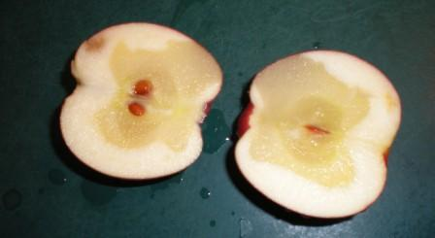The sap is sweet with sorbitol, a kind of sugar alcohol, and maybe other sugars as well. The area of flesh affected tends to be in the cortex, close to the vascular bundle in the centre of the fruit. Typically, the fruit gives no outward sign of this condition, which can be worse in some seasons than others, being weather dependant. There are several theories as to how this occurs, as sorbitol is not present in normal tissue. Low night temperatures in autumn and high day temperatures when apples are nearing maturity favour watercore. Low fruit calcium and high levels of nitrogen may increase the chance of watercore in susceptible varieties such as Braeburn, Red Delicious and Fuji. Over maturity at harvest and light crops of large fruit also favour the disorder. Apples with watercore are quite safe to eat and juice, and will be sweeter than apples of the same variety without this condition, but they will deteriorate in storage. In Japan, these apples are preferred and highly prized. They are called “mitsu” or honeyed apples because of the colour and sweetness and command a premium price.
To reduce the risk of watercore, reduce the amount of nitrogen fertilizer applied. This will help to bring the nitrogen and calcium into a better balance. It's also important to harvest apples as soon as they mature to reduce the accumulation of excess sugar.

2020 SEASON REVIEW
What a strange season this was. We had about thirty inches of rainfall in just the first eleven weeks of the year before lockdown but only about two inches in the next eleven weeks to the end of May. The blossom was early and magnificent – if you missed it, check out the photos on the SLOG website Picture Gallery.
Several orchard problems were reported by SLOG members during spring/early summer. 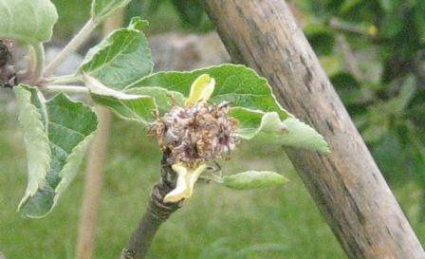1. A rather nasty frost in mid-May hit some orchards but not others, for example the SLOG orchard was so badly affected that it’s hard to find any fruit there. A consequence of the lack of fruit is that the trees then put all their energy into vegetative growth which means that summer pruning in August is advisable to control this excess vigour.
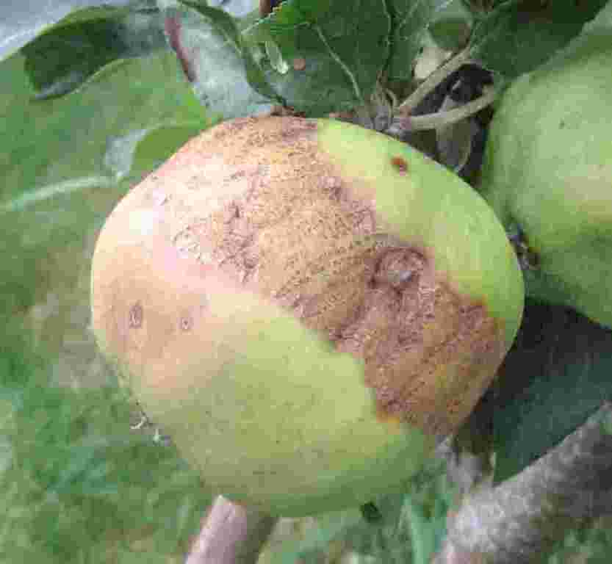
Where fruit did survive, some was badly scarred with a frost ring such as this Liddell’s Seedling.

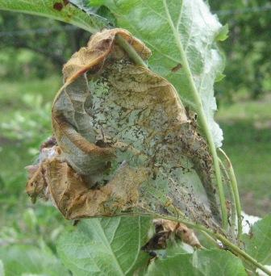2. The dry weather must have suited tent caterpillars which appeared after just petal fall, spinning webs that bound leaves together to protect the developing caterpillars which feed on the leaves and then in June fall to the ground to pupate. If you see them next spring, just pick them off and bin them.
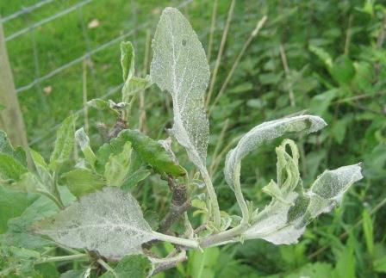3. Powdery mildew is predominantly an apple disease of dry climates such as East Anglia, characterised by the white dusty appearance of infected foliage. However, the warm weather in April and May suited it so it became more frequent than in previous years. It is nothing to worry about on established trees, but can be a nuisance on young trees and any trees grown in containers, in which case just pick off the affected foliage and bin it.
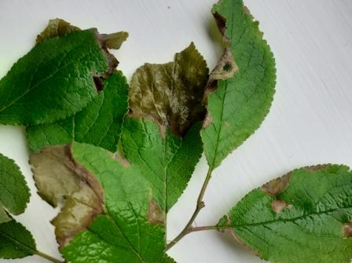4. Leaf scorch: During May we had some high winds with low humidity during a period of drought. This meant that young leaves, at a tender stage of development became dehydrated around the margins causing necrosis. The photo above (© Rachel Grimshaw) shows damson leaves, but pears are also sensitive, apples less so. The damage is only serious for a young tree, especially if under any other stress, but most trees will soon recover.
If you were a commercial grower you might be thinking about installing a windbreak on the north-east side of your orchard because this is where the most damaging winds blow from.
An article on windbreaks appeared in SLOG newsletter #30 of winter 2016 which can be found on the SLOG website.
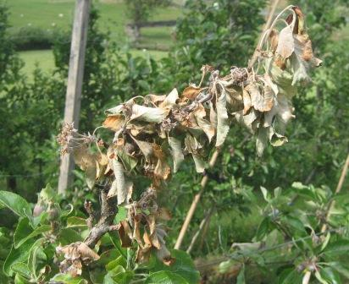5. Canker: We usually think of canker as a disease favoured by humidity, in other words a wet weather disease – but it also cropped up again despite the dry weather this spring. The photo above shows dieback resulting from infection of a pruned shoot.
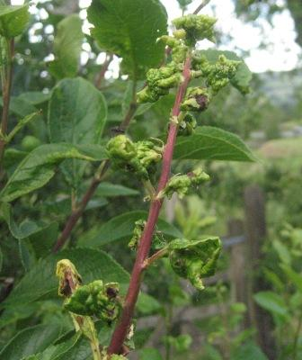 6. Aphids: This is an annual occurrence – the aphids appear at petal fall and their feeding activity on young growth results in this characteristic leaf curl. The photo shows damage on a mirabelle plum, but the symptoms are just the same on all top fruit. Although the appearance is unpleasant, the damage is basically cosmetic and provided the tree is well established it can tolerate and grow away from the effects. After a while, predators arrive to control the aphids but on a young tree which is more likely to suffer a growth check, the aphids can be deterred with a soapy water spray.
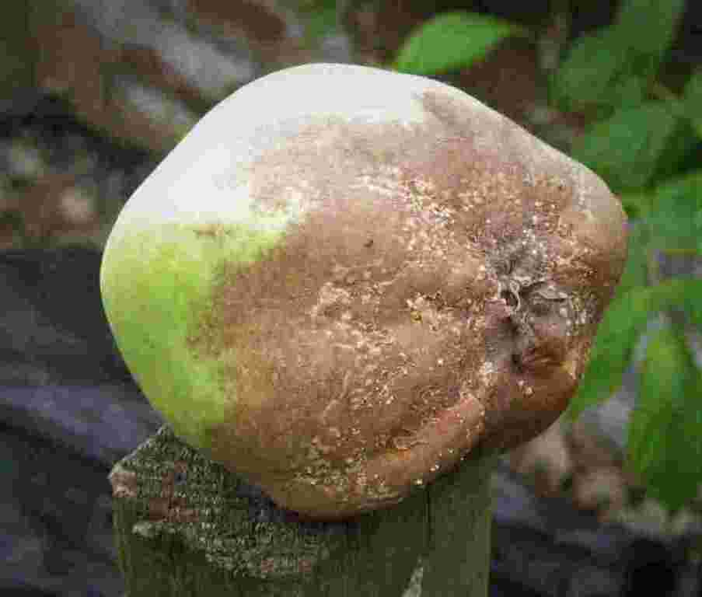
7. Brown rot (Monilinia fructigena) seems to be more frequent this season. It is caused by the same fungus as blossom wilt. Affected fruit should be removed from the tree and destroyed before the fungus moves on to adjacent fruit. The example above is a Keswick Codlin, one of the few varieties in the SLOG orchard which managed to carry a crop of fruit this year.

NEW APPLE VARIETY: FLANDERS PINK
The first UK-grown pink apple variety was harvested in commercial quantities for the first time last year. Flanders Pink is named after its producer AC Goatham's Flanders Farm in Hoo, Kent, who hope it will help reduce imports by competing with other pink skinned varieties such as Pink Lady. Described as sweet, crisp and very juicy, the new variety will help fill a gap in the market for British growers, with pink varieties up until now almost exclusively having been grown overseas and imported because the UK climate cannot provide the amount of ultra-violet light and heat units they need for their colour and flavour to develop to maturity. 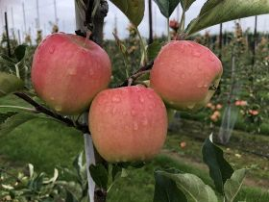 Carol Ford, commercial director of AC Goatham & Son, said: “This is an exciting development for our team which has taken significant investment and collaboration to produce and we are delighted with the results – the very first commercially grown British pink-skinned apple. Flanders Pink has scored highly in the all-important consumer taste tests as well as being suitable to grow in the UK’s damp climate. It also travels and stores well – vital for modern apple varieties, so that they reach the end consumer in the very best condition.” 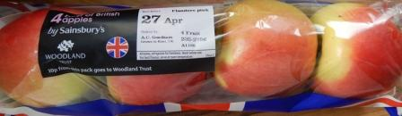Flanders Pink is the result of a cross between Kanzi and Greenstar by a Belgian breeder and small quantities were sold by Sainsbury’s (above) last year. AC Goatham are Britain’s biggest top fruit producer, supplying over 350 million apples annually, a quarter of UK production. Their website features the new variety but is just marketing blurb: https://www.acgoatham.com/goodness/flanders-pink with acknowledgements to “Fresh Produce Journal”
HILARY’S APPLE STORIES
When asked which is my favourite apple I usually say Ribston Pippin. Of course, I have many favourites but the Ribston was one of the first grafts I did. One reason I like it is that we know its full history. It was a seed brought from Rouen by Sir Henry Goodwin circa 1688 and planted at his home Ribston Hall near Knaresborough. The original tree died in 1835 but a sucker grew up which lasted until 1928 It has distinctive flavour which it has passed on to its famous daughter the Cox’s Orange Pippin.* 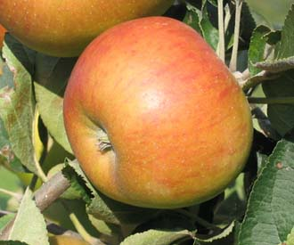Ribston Pippin ©Keeper’s Nursery The Ribston is a triploid and therefore a strong grower and more disease resistant than Cox so better suited to the North.
I got the scion wood for my grafts from a lady who lived in the village where I was brought up just outside York. I went to school with her daughter and used to play in their orchard when a child. I was pleased to have several successfully grafted trees so I kept one, gave one to my parents and took one back to the owner of the tree. She was delighted and told me her grandfather had gone back to the original tree in 1909 for the scion wood to graft the tree in her orchard. About ten years ago I went back and grafted trees for her daughter and grandchildren and I have a step-over from it at Appleby and it is as near the original as one can get. The reason I started grafting trees was because I had moved to Cumbria and found that the trees my parents gave me which did well in the York area did not succeed in the bottom of the Lune gorge where spring arrives late and the rainfall is heavy. I was given the apple trees, some rhubarb, Royal Sovereign strawberries and blackcurrants because my parents fully expected that I would continue the family self sufficiency tradition. Their house was in a village which followed the medieval pattern and each house had a long garden. Some had been market gardens with fields beyond the gardens and some had been farms. Following the second world war, in view of food shortages everyone grew as much of their own food as they could. We had hens and a pig as well as fruit and vegetables. It was much like “The Good Life” TV programme. I was used to picking a particular apple for a particular purpose. James Grieve was for an early dessert and Laxton’s Superb for a late one. Reverend Wilks was the one to go with the blackberries and Howgate Wonder and Monarch were the ones we stored and kept for pies and puddings until the early rhubarb was ready. Our blackcurrants were cuttings from the agricultural college at Askham Bryan. My grandfather pruned them for the college in 1939 when the staff and students went to away to war. I have never known the variety which has small berries but does not get big bud. That takes me back another generation but in fact I have five generations of fruit growers in my family. It began when John Benson married his cousin Ann Benson and went to work for Backhouses, a famous nursery near York. Whilst my great grandmother, known as Paley thought nothing of wringing the neck of thrushes eating her strawberries, her much younger sister was brought up with the Backhouse children and that side of the family was thought to be ‘posh’. Paley was my great grandmother’s middle name and she and her husband John Braithwaite grew fruit for a local confectionary firm and until as the family story has it, the firm found it could get fruit pulp cheaper from Russia! My grandmother, Florence, grew up picking fruit and I remember she taught me how to pick gooseberries. One held the branch taut so it does not spring back and scratch ones hand. However she escaped from farming and became a school teacher. My grandfather was also a school teacher and having lived through two world wars their garden and orchard was there for self sufficiency reasons. One of my earliest memories was of being stung by a wasp whilst picking a plum but on a happier note I remember the neighbours saying to my grandad, “How’s your Lane’s Prince Albert Joe and how’s your Peasgood Nonesuch?” I would have been five at the time so it must have made a big impression! 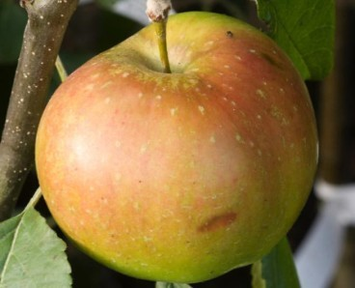 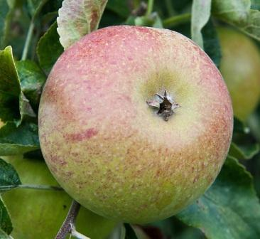 Lane’s Prince Albert Peasgood’s Nonesuch © Ashridge Trees © Alan Buckingham Although when I moved to Cumbria, I lived in probably the worst place in England for growing apple trees I saw there were apple trees in the area and I started looking at local varieties and good survivors in old orchards. I found Cumbria had several local varieties but one could not see them anywhere so when the opportunity came I went on a short holiday with my husband to see the collection at Brogdale. Unfortunately they showed me the best Kidds Orange Red which was in season at the time, If I had known I could have asked for a guide and seen the Keswick Codlin, Duke of Devonshire and Greenups Pippin. My next step was to go to Harlow Carr in Harrogate to learn to graft and I bought rootstock and scion wood and grafted the local trees. Spring was late so I put the rootstock inside the buildings at the farm and they were beginning to grow when I did the grafts. I was delighted to be successful with nearly every graft and after meeting the head gardener Chris Braithwaite at a talk I passed some spare ones on to Acorn Bank, a local National Trust property, with the idea that people could see their local varieties in their own area. Soon after this an organisation called Common Ground encouraged the idea of Apple Day, to celebrate local history as each area has its own varieties and these were being lost as old orchards disappeared. I was asked to identify apples at Acorn Bank’s first Apple Day and in an effort to expand my knowledge I went to the one at Harlow Carr to consult the expert Ernest Oddy. I met with other enthusiasts and became a member of the Northern Fruit group and the rest as they say is history! Hilary Wilson (article originally written for the Northern Fruit Group’s Newsletter)
* Recent DNA research on apple parentage has concluded that this long-held assumption is false and that these two varieties (Ribston & Cox) are siblings; their common parent being Margil.

ROOTSTOCK ORDERS
As per previous years, SLOG will consolidate orders from members for rootstocks for delivery in January 2021 in time for grafting. Rootstocks available include: Apple:MM106/MM111/M25/M26/M9/M27 Pear:QuinceA/C/Pyrodwarf Plum: St. Julien A/ Krymsk VVA1 We have a trade account with Matthews so if there is anything else you’d like to purchase from the Matthews website: http://www.frankpmatthews.com/ just add it to your rootstock order and we should be able to get it at a useful discount from the retail price and without you incurring carriage costs. Apple rootstock prices vary between £1-£2.50 each depending on total numbers ordered. Email Andy Gilchrist at andyjgilchrist@hotmail.co.uk or phone 01539 727772 to place your order. Deadline for orders is the end of September.
GRAFTING TO ORDER
The SLOG grafting to order service is again available this winter. If you want a particular variety on a particular rootstock, it can, subject to availability, be grafted for you. Adele Jones is the co-ordinator for this service. Price is unchanged at £15 per tree, buyer collects. Call Adele on 015395 52102 for enquiries & orders.
SLOG SHOP
1. SLOG has a range of container grown maiden apple trees for sale at £15.00 each, comprising traditional varieties suitable for our Northern climate mostly on MM106 rootstocks. Visit https://www.slorchards.com/trees-for-sale to see the list and for guidance on purchase and collection.
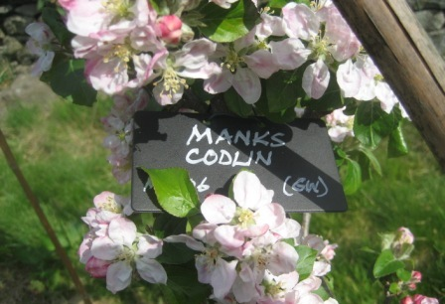2. Wells & Winter labels are the most cost-effective permanent solution for recording tree variety identity. They are rigid black plastic labels measuring 2 x 3½” (5x9cm), giving a permanent and very visible result. They are available at 15p each.

3. Apple Notelet cards £2 per pack of 5 different cards each featuring a different apple variety. 4. Recipe books: 28 full colour pages detailing 45 recipes for a wide range of fruits only £2.50.

4. Recipe books: 28 full colour pages detailing 45 recipes for a wide range of fruits only £2.50.

5. The Apples & Orchards of Cumbria: Lavishly illustrated with over 100 full colour photos describing the twenty or so Cumbrian apple varieties and the fifteen orchards open to the public. Judged runner-up in the “Landscape & Tradition” category of the Lakeland Book of the Year Awards, 2014. £9

All the above items are available at SLOG events such as Shows, Apple Days and the Winter Talk.
SLOG Discount at Suppliers: Rogers & Beetham Nursery
SLOG has negotiated a 10% discount at Rogers of Pickering for SLOG members. When you place an order for any kind of fruit: trees, bushes, etc., quote your SLOG membership number and Rogers will apply 10% discount to your total bill. For mail orders go to: http://www.rvroger.co.uk/?linksource=frontpage
We also have a 5% discount at Beetham Nursery applicable to all items. Just show your SLOG membership card at the checkout.
TAILPIECE
“The Apple of Your Eye” is a quarterly publication, the next one being the winter issue due mid-November. Contributing articles, preferably in word.doc, are welcome, along with photos where possible, by the end of October 2020 to: andyjgilchrist@hotmail.co.uk

Disclaimer - The information in this newsletter is provided on the understanding that SLOG makes no warranties, either expressed or implied, concerning the accuracy, completeness, reliability, or suitability of the information. Nor does SLOG warrant that the use of this information is free of any claims of copyright infringement.

The opinions expressed in this publication do not necessarily represent the views of SLOG.
© 2020 South Lakeland Orchard Group

