In this Issue
Editorial | 1
Forthcoming Events | 2
Recent Events | 2
SLOG Orchard Update | 3
Plagues & Pestilence: 1. Nutrient Deficiences | 3
Plagues & Pestilence: 2. Apple Mildew | 4
Heritage Apple Variety Review:  Black Gillyflower | 5
Safety Standards for Gloves | 5
Wildflowers & Beneficial Insects | 6
The First Multifruit Tree | 7
DNA Analysis | 7
SLOG Shop | 8
SLOG discount at Suppliers | 8

Editorial

Every year the weather is different, but for the first four months of this year, the rainfall total at 23” has been very similar to each of the last two years. However the big difference has been the temperature which was very mild over the winter months of December to February but turned cold in March and April so that blossom was significantly delayed. The warm dry weather in May changed all that so that we have had a very rapid and condensed blossom period. The pollinating insects have been busy so that all bush and top fruit appear to have a good fruit set and may well need thinning in due course. There is also a risk that the high winter rainfall may have leached nutrients out of the root zone, so see page 3 for symptoms and remedies. Also, the dry weather in May has given rise to more apple mildew than usual, so see page 4 for more detail on this problem and how to deal with it.
Just after the last issue of this Newsletter, we were saddened to hear of the passing of our first Membership Secretary and founder member, Brian Fereday. Brian had a passion for Westmorland orchards, as his book of poetry, Homeground, demonstrates. He wrote and published this book despite the difficulties of motor neurone disease and it is an outstanding legacy to a remarkable man. Levens Chuch was packed to standing room only for his funeral and part of the collection was donated to SLOG. We plan to use some of this to plant a row of cordon pears at Sizergh Castle orchard (where Brian worked) and dedicate it to Brian. More news on this will be provided in due course.

A Gooseberry Show! A hundred years ago, gooseberry shows were hugely popular and very competitive all over the north of England. But like many country customs, they fell into decline in the face of other more modern pursuits. SLOG aims to revive this custom here in the South Lakes by holding a gooseberry show at our AGM on 26th July.
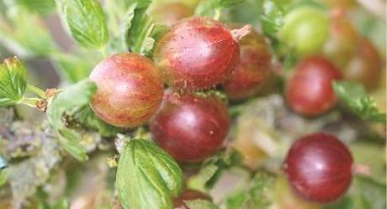So cultivate and feed your gooseberries carefully this season and bring your biggest gooseberry to compete at the AGM. Also, if you grow currants, bring along your best entire strig of blackcurrants, red & white currants for judging. Keep an eye out for gooseberry sawfly which can strip the leaves off your bushes in just a few days.

FORTHCOMING EVENTS

For the most up-to-date information look in: http://www.slorchards.co.uk/SLOGevents.html

Saturday & Sunday from 10am 4th & 5th June – CountryFest The SLOG stand will be in the Countryside Marquee. Drop in for a taste of Bob Bradley’s famous cider, our full-bodied apple juice, or just for a chat. For info see: www.westmorlandshow.co.uk/country_fest.html
Directions: From M6 jnctn36, take Kirkby Lonsdale exit to next rdbt then first left onto A65 for approx ½ mile, turn left onto B6385 over canal, showfield on rt
Saturday June 25th – Sizergh Castle Summer Fete Watch website for more info.
Sunday 3rd July – Summer Orchard Visit Meet at 2pm in the car park of Halecat Nursery (follow brown signs) for a guided walk around several orchards in Witherslack
Tuesday July 26th 7.30pm – SLOG AGM at Levens Institute This is your chance to air your views on what SLOG should or should not be doing and help shape our future strategy. There will be guidance on how to hand thin your apples, plus a gooseberry and currant show. Directions: From M6 jnctn 36 go 4 miles on A591 towards Kendal, then A590 Barrow, then after 2 miles turn right signposted Levens. Go to centre of village, Institute is on crossroads across from Methodist Chapel. Park on roads nearby.
Saturday August 13th 1.30 – 4.30pm – Budding & Summer Pruning Workshop, Growing Well, Sizergh Learn the skill of budding which nurseries prefer over grafting, and if your bud does not take, you can still graft onto the rootstock next spring which means you get two chances of success instead of one! Summer pruning is a useful means to slow the growth of over-vigorous trees. Bring your own secateurs if you have them. Directions: From M6 jnctn 36 go 4 miles on A591 towards Kendal, then A590 Barrow, then shortly on right follow brown signs for Sizergh Castle, then Low Sizergh Barn. From Kendal go 3½ miles south on the A591 then just before the A590 interchange turn left into the car park at Low Sizergh Barn Farm Shop and Tearooms. Park at the far end of the car park and walk over the fields. Admission: Free to SLOG members. There will be a charge for the rootstock.

RECENT EVENTS

GRAFTING WORKSHOP Saturday 5th March, Growing Well
About 20 members gathered in the yurts at Growing Well to learn and practice the art of grafting apple trees. Phil demonstrated splice and whip & tongue grafts and then members set about grafting using scion wood from a wide selection of over a hundred apple varieties onto MM106, MM111, M26 and M9 rootstocks.
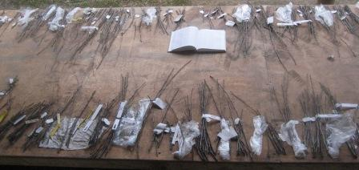A selection of scion wood ready for grafting
If you were able to grow on your grafts in a glasshouse or polytunnel, you can usually tell by the end of April whether they have taken or not. If kept outdoors, the take may not be definite until the end of May.
Once the take is clear, select the strongest growing bud and rub out the others then put a cane in the pot and tie in the growth as it develops. Carefully remove the grafting tape in June or July but keep the young trees in a sheltered position until planting out from November onwards.
The surplus rootstocks were subsequently taken to Witherslack a few days later where committee members grafted almost 100 trees which were potted up for growing on under Adele’s supervision ready for sale later in the year.

DAMSON DAY Saturday 16th April, Lyth Valley
Damson Day was cancelled this year for the first time in its 14yr history. The wet winter had kept the fields waterlogged for weeks on end and the final straw was an inch of rain on the preceding Tuesday. A site inspection on Wednesday reluctantly concluded that ground conditions were unacceptable. Sod’s Law naturally delivered a fine dry Saturday (too late) and to rub salt into the wound, the entire following week without rainfall! The organisers hope to hold a replacement event around harvest time. For more information see the WDA website: http://www.lythdamsons.org.uk/index.html

SLOG ORCHARD UPDATE
All trees have survived the winter and spring growth emerged slowly. Some of the pears opened their blossom in April but suffered frost damage as shown (on left) below:
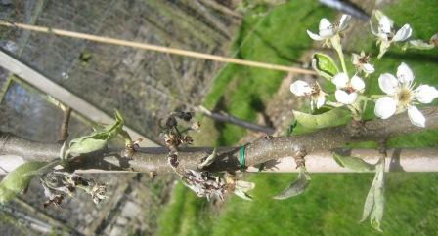 The apples blossomed in May and are now setting fruit. The first working party of the year took place on the morning of Saturday 27th February. We planted two more trees, bringing the total up to 170. All trees received a dressing of blood, fish & bone; and we dug out the compost heap and spread it around most of the trees, especially those at the top end of the orchard where the soil is lighter and drier. The Cumbrian varieties were pruned to provide scion wood for the following week’s grafting workshop. The stones washed into the alleys by Storm Desmond were cleared back into the rows, and all tree ties were checked and loosened where necessary.
A group of allotment holders are tidying up the parking area off Hallgarth Crescent and SLOG has donated three trees to be espaliered along a south facing wall. The varieties are: Minchull Crab, Golden Glow & Bellisime d’Hiver.
The next Working Party will probably be in summer for weeding, adjusting ties & canes and some relabelling. The site plan and variety list can be found on the SLOG website at: http://www.slorchards.co.uk/orchard.html
The orchard is on the Underley Road Allottments, situated between Underley Road & Hallgarth Circle just east of Windermere Road, Kendal.

“PLAGUES & PESTILENCE” 1. NUTRIENT DEFICIENCES
A possible consequence of the recent wet winter is that a significant amount of soil nutrients may have been leached down from the topsoil and out of reach of tree roots. This will be a particular risk for young trees and those on dwarfing or semi-dwarfing rootstock. If trees fail to thrive, despite adequate soil preparation, watering and mulching, it may be a sign of a nutrient deficiency. Containerised trees are particularly vulnerable, as those growing in very acid or alkaline soils. Yellow or reddish coloured leaves, stunted growth and poor flowering are all common symptoms of nitrogen, magnesium or potassium deficiency.
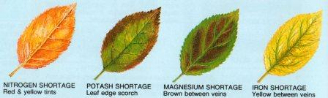illustration courtesy of “The Fruit Expert”, Dr. D. Hessayon
The symptoms, causes and remedies are:

Nitrogen deficiency
Symptoms: Spindly yellow plants or yellow leaves, sometimes with pink tints. Cause: Nitrogen promotes green, leafy growth and deficiency results in yellowing and stunted growth. Nitrogen is very soluble, so is easily washed out of the soil in winter rains, leaving the soil deficient in spring, just when plants are putting on new growth. Nitrogen deficiency is a common cause of yellow leaves in spring. Remedy: In the long term, mulching with organic matter (such as well rotted garden compost or manure) provides a steady trickle of nitrogen to stabilise levels. In the short term, applying high nitrogen fertilisers such as sulphate of ammonia or poultry manure pellets will remedy the problem.

Potassium deficiency
Symptoms: Yellow or purple leaf-tints with browning at the leaf edge and poor flowering or fruiting.
Cause: Potassium is needed for controlling both water uptake and the process allowing plants to harness energy from the sun (photosynthesis). Potassium promotes flowering, fruiting and general hardiness. Shortages are more likely on light, sandy or chalky soils where potassium is easily washed away. Clay soils, by contrast, hold potassium within their structure. Remedy: Apply high potassium fertilisers such as sulphate of potash, tomato feed or certain organic potassium sources derived from sugar beet processing.

Phosphorus deficiency
Symptoms: Slow growth and dull yellow foliage. Cause: Phosphorus is needed for healthy roots and shoot growth. Soil shortages of phosphorus are rare, but may occur in areas with high rainfall and heavy clay soil. Remedy: Apply fertilisers such as superphosphate or bone meal.

Magnesium deficiency
Symptoms: Yellowing between the leaf veins, sometimes with reddish brown tints and early leaf fall. Cause: Magnesium is needed for healthy leaves and for plants to harness energy from the sun (photosynthesis). Soil shortages of magnesium are more common on light, sandy soils. Over-use of high-potassium fertilisers (such as tomato feed) can cause magnesium deficiency, as plants take up potassium in preference to magnesium. Remedy: In the short term, apply Epsom salts as a foliar feed in summer. Dilute the salts at a rate of 20g of Epsom salts per litre of water (1/3oz per pint) plus a few drops of liquid detergent. Apply two or three times at fortnightly intervals, spraying in dull weather to avoid leaf scorch. In the long term apply to the soil around the roots either Dolomite limestone (calcium-magnesium carbonate) at 100g per sq m (4oz per sq yd) or Epsom salts (magnesium sulphate) at 30g per sq m (1oz per sq yd). Dolomite limestone will make the soil more alkaline, so should not be used around ericaceous (acid-loving) plants such as rhododendrons or camellias, or where the soil is already alkaline.

Manganese and iron deficiencies
Symptoms: Yellowing between the leaf veins with browning of leaf edges on acid-loving plants. Cause: Manganese and iron are important for allowing plants to harness the energy of the sun (photosynthesis). Soil shortages are rare, but manganese and iron can be unavailable to plant roots in alkaline conditions. Ericaceous (acid-loving) plants are particularly vulnerable when growing in alkaline soils or potting composts. Remedy: Apply chelated iron and manganese treatments, such as Sequestrene, to the soil around the plant roots.
With acknowledgement to The Royal Horticultural Society

“PLAGUES & PESTILENCE” 2. APPLE MILDEW

The warm weather of May has thrown up a higher incidence of apple mildew (Podosphera leucotricha) than in previous years. 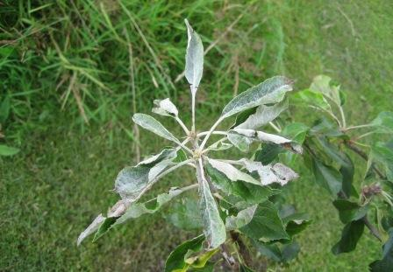
This is very much a warm dry weather disease which is uncommon in Cumbria for obvious reasons. The symptoms as shown above, a white powdery film across new leaves, usually appear only on those opening from one or two buds. The most susceptible varieties are Cox’s Orange Pippin, Lane’s Prince Albert, Jonathan and some of the newer varieties. There is no need for chemical treatment: just pick off all the affected foliage and destroy it.

HERITAGE APPLE VARIETY REVIEW: BLACK GILLYFLOWER
This is a variety which you will not find in any English apple literature yet it is believed to be a very old English apple which was taken to America by the early settlers, but lost its identity here. Newsletter #18 of winter 2013 carried an article by Phil Rainford on Lady’s Finger of Bledington. 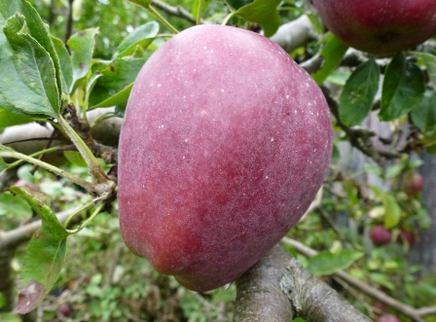This had been assumed to be a Cotswold apple whose earliest known record was c1850. However, Phil recently received some interesting news from Derek Tolman of Bernwode Fruit Trees. Derek advised “About 15 years ago we got scionwood of Black Gilliflower from the USDA collection in Geneva, USA. It has fruited several times as has the ‘Lady’s Finger of Bledington’ After the excellent fruiting of both this year (2015) we are now absolutely certain that this Lady’s Finger of Bledington and Black Gilliflower are the same. Black Gilliflower has absolutely no record in British literature, which is rather odd, but the name, the shape and the nature have always led us to believe it is English and taken out to America with settlers. Gilliflower, also retrieved by us from America, has a similar shape. In America there is no known origin but it has been recorded in the late 1700s under this name and some American writers say it was known there in the early 1700s. This is the earliest and almost certainly correct name. Now that we have an early reference for it in England, albeit now with a different name, I think we can now assert that Black Gilliflower is an English apple and that it was in America certainly as early as the 1770s-1780s, when the Americans were ungratefully pushing us out of America.” Derek showed us fruit from both his Black Gilliflower and Lady’s Finger of Bledington and they were clearly the same, being so distinctive that confusion with any other Lady’s Finger could not be possible.
SAFETY STANDARDS FOR GLOVES
Readers, especially grafters, may recall that we recommend a glove be worn on the non-knife wielding hand when grafting to protect against the risk of inadvertent bloodshed. But what kind of glove? SLOG member and keen grafter Brian Bennett has written this review of safety gloves.
Next time you walk over a manhole cover you might see the symbol EN124 or sometimes this might be BS EN 124 or even very occasionally DIN EN 124. These are symbols representing the European Standard EN124 whilst the letters BS and DIN represent British Standards and Deutsches Institut für Normüng respectively, ie the local version of the standard in the national language. European Standards cover many objects we take for granted including gloves particularly those used in industry and the public sector. The gloves one might buy at a garden centre or supermarket are usually gloves designed for industry that have been repackaged for the consumer market and normally you would expect a label or the glove itself to be marked with the appropriate standard Occasionally you might find gloves that are called safety gloves on the packaging but with no other marking and that might mean they have not been assessed correctly as all gloves claiming to safety gloves should have at least the CE mark on it.
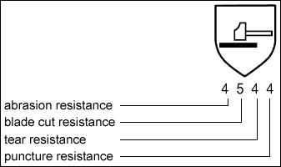The glove standard most appropriate for gardening is the standard EN388 otherwise known “Protective gloves against mechanical risks”. Gloves conforming to this standard are tested for 4 potential hazards namely abrasion resistance , cut resistance , tear resistance and puncture resistance and the results are shown on a so-called pictogram such as the one shown. With the exception of cut resistance which has 5 levels the hazards have 4 levels of protection with level 1 being the lowest level and 4 or 5 being the highest level. So a typical leather glove might have the levels 3143 which mean that it has pretty good abrasion, tear and puncture resistance but not very good cut resistance. On the other hand there are some special textiles available which give excellent cut resistance so you might use one of these for grafting when you are using a sharp knife and a leather glove with good puncture resistance for pruning roses. Generally these tests are carried out on the palm of the glove so the results do not necessarily apply to the back of the glove so you might wish to use an all leather glove rather than a glove with a leather palm and cotton back for trimming a hedge which has hawthorn and sloes in it. Anyone who has an allergy might wish to note that to comply with EN388 a glove must also comply with EN420 which basically means that it must not contain any materials that might cause health problems. However if someone is allergic to some of the proteins in rubber or the chromium in leather they might still wish to choose another material.

There are several others glove standards including ones for chemicals and chain saws as well as heat. Rubber and plastic gloves are normally used for handling chemicals but one must be particularly careful about using this standard as many chemicals are known to permeate such gloves without any apparent effect on the glove and gloves from different materials give protection against different chemicals so a natural rubber glove might give good protection against one chemical and nitrile rubber good protection against another. Sometimes you might find when buying pesticides that the manufacturer recommends a specific rubber or plastic glove so generally it would be wise to use this material. Clearly gloves are very useful if used correctly but no gloves are 100% proof against any particular hazard and this is perhaps illustrated by gloves that give protection against chain saws might just give the user a fraction of a second to get his or her hand out of the way . Heat resistant gloves (EN407) are also widely used in industry often to quite high temperatures and like EN388 the gloves have different levels of performance against different hazards so it is possible to buy heat resistant gloves that burn because they are only designed to be used at relatively low temperatures. It is not just the man in the street who can make such a mistake as many years ago at the scene of a major fire in London the firefighters are said to have been wearing plastic gloves which melted on their hands. As result a new standard for firefighters' gloves was developed. Many glove standards are in effect composite standards so the firefighting glove standard is actually a mixture of performance levels for mechanical hazards such as cut and puncture as well as those for heat. It is even possible to build in performance levels for cold resistance into firefighting gloves.

There are several other standards in addition to those mentioned above but perhaps the main point is that it is important to wear the correct gloves when doing something potentially hazardous and if you are in any doubt contact a reputable supplier as they should be able to help. So next time you have a bonfire make sure it is the correct type!

Courtesy Brian Bennett

Wildflowers and Beneficial Insects
We probably all assume that wildflowers in and around an orchard provide a safe habitat for beneficial insects which in turn will subdue pest populations, reduce fruit damage and increase pollinating insect activity. Nevertheless, it is reassuring to have a scientific study test the theory and validate the assumption. East Malling Research Station has recently conducted such a study entitled 'The effect of wildflower strips in orchards on pollination services' with the objectives: Habitat creation - Pollinator and natural enemy diversity and abundance - Pollination and pest regulation service - Cost benefit analysis. The wildflower species were Knapweed (Centaurea nigra); Lady's bedstraw (Galium verum); Rough hawkbit (Leontodon hispidus); Selfheal (Prunella vulgaris); Oxeye daisy (Leucanthemum vulgare); Orchard grass (Dactylis glomerata); Yarrow (Achillea millefolium) & Red clover (Trifolium pratense). The results showed that the orchard area with wildflower strips had increased numbers of Anthocorid bugs and Clubionid spiders along with decreased numbers of Rosy apple aphid.

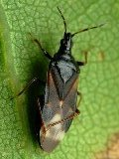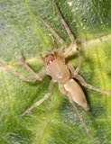
Anthocorid bug Clubionid spider
The wildflower strips also had increased pollinator (honey bees, bumblebee & hover flies) visitation, resulting in a slight increase in fruit size, weight and seed numbers.
Report courtesy of The English Apple Man
One further observation – nettles are one of the best hosts for anthocorid bugs, which are worth encouraging as they are the main predator of aphids and pear sucker.

THE FIRST MULTIFRUIT TREE
Phil Acock, Managing Director, Fourayes Farm Ltd, of Sittingbourne, Kent recently announced a breakthrough in multifruit grafting:
“One of the major challenges we have, when making our mixed English fruit jam, is the complexity and cost involved in getting all the right fruit, from a wide variety of sources, together in one place for production. So, we experimented with grafting. Our premise was that if the Bramley apple can only be grown by grafting onto a different rootstock, why couldn’t other fruits be grown in the same way; perhaps even several types of fruit on a single tree rootstock? Success would lead to huge savings in harvesting costs, efficiency gains in pruning and, of course, bringing all the fruit for our mixed English fruit jam from a single orchard, would create huge transport cost savings, as well as ensuring that every type of fruit used would be at its optimum freshness.
Our hypothesis was that if a graft on a rootstock could produce Bramley apples, would a graft from another type of fruit, onto the Bramley apple graft itself, be far enough removed from the original to allow a completely different type of fruit to grow?
With a clean sheet of paper available to us (we are not aware of anyone having succeeded in this area to date), our Farm Manager, Ian Witherden, worked closely with leading arboriculturist and expert in rootstocks, Dr Hugh Chester, across a wide range of British top-fruits and soft fruits.
We had some early successes with other top fruits: producing pears from a Bramley graft on an M22 rootstock that presented with a cell structure that held up under extreme cooking conditions. In fact, it became clear that a critical key to success is the rootstock; the M22 being particularly appropriate due to its accommodating and benign nature, and its high salt tolerance.
However, the rootstock is only a part of the story: another crucial component is the feeding regime for the trees.
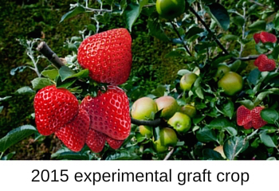 By mimicking the feeding regime for the non-apple fruits, we started to discover that the fruit graft-on-grafts would respond favourably.
It’s early days of course, but the result, some seven years later is, as far as we are aware, the very first English strawberries grown, not at ground level or in poly-tunnels, but entirely above ground on trees.”
The date of this press release? 1st of April!
DNA ANALYSIS
East Malling Research Station in Kent has established a database of DNA profiles for all the varieties in the National Collection at Brogdale. They now offer a testing service based on DNA analysis to identify varieties of top fruit. This service costs £300 per sample, effectively putting it out of reach of private individuals and even voluntary community groups such as SLOG. However, the national organisation “Fruit ID” which seeks to characterise the widest possible range of varieties has negotiated an agreement with East Malling whereby they will act as the co-ordinator for bulk orders from fruit groups such as SLOG around the country. On this basis, the price for apples falls to £24 and for pears £29.50 It is important to note that the service only provides a DNA analysis and match to database. This means that if we know a variety is a new seedling, it will not be on the database, and the reply will simply be “unidentified”. They are not able at this pricing level to provide any speculation about parentage. Nevertheless, this offers the possibility to identify remnant trees which have been grafted and therefore should be a recognised variety. Consequently SLOG has notified Fruit ID that we will submit samples of apple and pears for analysis. The process involves taking leaves in June and posting them to East Malling. The samples will be frozen on arrival at East Malling, and then all samples analysed in autumn. We expect to get answers in mid-November. If any SLOG members wish to have any apples or pears analysed via this service at the special prices shown above, please email andyjgilchrist@hotmail.co.uk or phone 01539 727772 before the end of May. For more detail on these two organisations, see their websites: http://www.fruitid.com/#main http://www.emr.ac.uk/commercial-services/dna-testing/
SLOG SHOP
1. SLOG has a range of 1yr old container grown maiden apple trees for sale at £13.50 each, comprising traditional varieties suitable for our Northern climate on MM106 rootstocks. Visit http://www.slorchards.co.uk/TreesForSale.html to see the list and for guidance on purchase and collection. 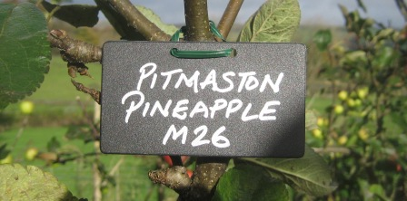2. Wells & Winter labels are the most cost-effective permanent solution for recording tree variety identity. They are rigid black plastic labels measuring 2 x 3½” (5x9cm), giving a permanent and very visible result. They are available at 15p each along with a deposit for the silver pen (if taken away)
3. Recipe books: sold out but a reprint is under consideration.
4. Apple Notelet cards £2 per pack of 5 different cards each featuring a different apple variety. 5. The Apples & Orchards of Cumbria: Lavishly illustrated with over 100 full colour photos describing the twenty or so Cumbrian apple varieties and the fifteen orchards open to the public. Judged runner-up in the “Landscape & Tradition” category of the Lakeland Book of the Year Awards, 2014. £9
All the above items are available at SLOG events such as Workshops, Shows, Meetings and Apple Days.
SLOG Discount at Suppliers: Rogers & Beetham Nursery
SLOG has negotiated a 10% discount at Rogers of Pickering for SLOG members. When you place an order for any kind of fruit: trees, bushes, etc., quote your SLOG membership number and Rogers will apply 10% discount to your total bill. For mail orders go to: http://www.rvroger.co.uk/?linksource=frontpage
We also have a 5% discount at Beetham Nursery applicable to all items (except in the café). Just show your SLOG membership card at the checkout. www.beethamnurseries.co.uk/
TAILPIECE
“The Apple of Your Eye” is a quarterly publication, the next one being the autumn issue due mid-August. Contributing articles, preferably in word.doc, are welcome, along with photos where possible, by the end of July 2016 to: newsletter@slorchards.co.uk

Disclaimer - The information in this newsletter is provided on the understanding that SLOG makes no warranties, either expressed or implied, concerning the accuracy, completeness, reliability, or suitability of the information. Nor does SLOG warrant that the use of this information is free of any claims of copyright infringement.

The opinions expressed in this publication do not
neccessarily represent the views of SLOG.

© 2016 South Lakeland Orchard Group

