In this Issue
Editorial | 1
Forthcoming Events | 2
Recent Events | 2
SLOG Orchard Update | 4
Frequently Asked Questions | 4
Plagues & Pestilence: Damson Bent Banana Disease | 5
New Apple Variety: Eden | 6
Willow Mulching | 7
Scion Wood Orders | 8
Grafting to Order | 8
SLOG Shop | 8
SLOG Discount at Suppliers | 8

Editorial

Our most important recent news was the awarding of National Plant Collection status by the UK governing body Plant Heritage to the SLOG Orchard’s “Malus domestica: North West English Apple Cultivars”. This is a prestigious award which very few other apple collections have earned; there are only five other such regional apple collections in England. A press release based on this news resulted in useful publicity for SLOG in local newspapers, radio and television. Meanwhile our fruit presses have been busy: both on hire by members, and at community apple pressings, of which we again did or attended six this year. A huge thankyou is due to Andrew Hockenhull for managing the bookings for the Spiedel Mill & Hydropress at Sizergh Castle and to Dick Palmer for managing the big press. The barrel press was again used by several local schools thanks to our partnership with Jan Quinn of the charity Chestnut Events.

SLOG needs a new webmaster: can you help? After doing a great job running the SLOG website for many years, Ros Taylor is stepping down at the end of 2019. We need a new webmaster to take on this role from January 2020. Ros will be available to help the transition and provide any mentoring required, so if you think this role could be for you, just chat to Ros to find out what is involved: Rosalind.taylor@gmail.com

There are changes also in our tree sales team. We are extremely grateful to Adele Jones & Mike Walford for managing SLOG’s tree sales operation from their base in Witherslack for many years. This has now been taken over by Kirsten Jones and Paul Atkins from a new base in High Newton, so for all tree purchase enquiries email: kirstatjoneskins@gmail.com & ackyboy@hotmail.com
This summer we again submitted a number of samples of apple and pear leaves to East Malling for DNA analysis. The results from past years show that we have discovered several previously unknown varieties which now need naming, so our Winter Meeting on 3rd December will review these varieties and together we’ll attempt to generate appropriate names for them (see details on page 2). We will also have the opportunity to taste members’ fruit-based preserves, chutneys and cakes, so if you have made some interesting fruit-based produce recently, please bring it along for all to sample.
Meanwhile if you still have your spring-grafted trees in pots, now is the time to plant them out. The sooner they are planted, the better established their roots will be when growth
starts in spring.

FORTHCOMING EVENTS

For the most up-to-date information look in: http://www.slorchards.co.uk/SLOGevents.html
Tuesday 3rd December – Winter Meeting 7.30pm Crook Memorial Hall Recent DNA analyses have demonstrated that we have discovered several unique varieties of apples and pears in local orchards. Until now, these varieties have been known only by code numbers but they now need proper names like any other recognised variety. At this meeting we will describe each variety and its location and then attempt to conjure up an appropriate name for it. Come along and join in the fun of naming our new babies! There will of course be refreshments, apple juice and socialising. Cakes etc welcome! Directions: From Plumgarth roundabout at the north end of Kendal, take B5284 direction Bowness. Go through Crook village, past the Sun Inn, then up the hill and the Hall is on your left at the top of the hill. Satnav LA8 8LG
Saturday 25th Jan 2020 - SLOG Pruning Workshop, Grange Community Orchard. 1.30-4.00pm. This workshop covers maintenance winter pruning, though all other types of pruning can be discussed on request. Bring your own secateurs (some will be provided). Directions: Near Grange-over-Sands railway station, just south of the B5277/B5271 roundabout, opposite the Ornamental Gardens. Car parking on opposite side of road or in nearby carparks.
Saturday 29th February 2020 2.00–4.30pm SLOG Grafting Workshop, Growing Well, Sizergh LA8 8AE Graft your own apple & pear trees using M26, MM106, MM111 & Quince A rootstocks and a wide range of scion wood varieties. Bring your own Stanley knife (a few will be provided) and gardening gloves for protection. Wear suitable footwear as the path to the yurts may be muddy. Directions: From M6 jnctn 36 go 4 miles on A591 towards Kendal, then A590 Barrow, then shortly on right follow brown signs for Sizergh Castle, then Low Sizergh Barn. From Kendal go 3½ miles south on the A591 then just before the A590 interchange turn left into the car park at Low Sizergh Barn Farm Shop and Tearooms. Park at the far end of the car park and walk over the fields. Rootstocks £2.50 each.
Saturday 11th April, Damson Day at Low Farm, Lyth Valley LA8 8DJ 10am - 4pm (Provisional date – to be confirmed) See http://www.lythdamsons.org.uk/index.html Directions: Take A590 to Gilpin Bridge, then A5074 direction Bowness for 2 miles toward Low Farm. Follow signs to car park in adjacent field.

RECENT EVENTS

Autumn Orchard Visit Sunday 25th August
About twenty members of SLOG and our sister group NCOG gathered at Dalemain on a warm sunny day. Hilary led us on a tour of the apple trees around various parts of the property. Many of the trees were quite old and records show that apple trees had been purchased from a London Nursery as far back as the late 18th C.
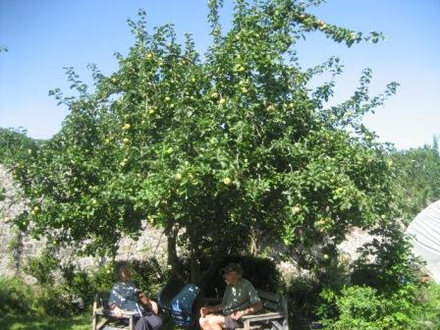The mystery culinary variety “Gloriana” which was identified by DNA analysis as “Nelson’s Glory”
We looked at free-standing and espaliered trees amongst the roses in the public part of the gardens, then Hilary led us into the private walled garden where a “timeline” of apple varieties has been planted, illustrating varieties from Roman times all the way up to the 21stC.

Budding & Summer Pruning Workshop Saturday 14th September
About twenty members gathered in the yurt at Growing Well where Hilary demonstrated chip budding and also late season grafting which can be done by cutting all the leaves off the scion wood. Since we had very few rootstocks, members practiced on spare pieces of apple wood. The weather was sunny and warm, in fact it soon became too warm in the yurts so we moved outside to practice summer pruning on the cordons, doing over a hundred of them.

MEMBERS APPLE PRESSING DAY Sunday 22nd September, Halecat
The day started with rain and looked unpromising. Fortunately, Tom & Abi have a nice little building which houses an informal self service café and seating area where we were able to set up the press just out of the rain, which gradually eased. Numbers of members were down on last year, perhaps because of the weather forecast, but pressing was steady through the morning, easing off in the afternoon so we finished around 3pm. Many thanks to Abi & Tom for hosting us and to Dick and Anthony for a sterling days work!

FORD PARK APPLE DAY Saturday 5th October
A busy day saw us press nearly a ton of apples. At one point in the morning the queue was an hour long so the Spiedel Mill and Hydropress were working hard. A better water supply than in previous years permitted more efficient and speedier working so by lunchtime the queue had evaporated and a quiet afternoon allowed us to finish at 3pm. Many thanks to SLOG volunteers Tony & Kathy plus Ford Park volunteers Chris & Dave.

LYTH VALLEY PRESSING Saturday 12th October
A case of third time unlucky for Hugh Connor at Low Farm when the Voran Mill fused electrical circuits mid-way through the day. Fortunately Chrissie & Nigel came to the rescue, bringing their press up from Lancaster to save the day.

ACORN BANK APPLE EVENT Saturday 12th October
Acorn Bank no longer run a proper Apple Day, but their “Apple Event” pulls in a fair number of folk wanting their apples identified, which kept a team of eight identifiers busy for a few hours.

BEETHAM NURSERY APPLE DAY Sunday 13th October
About thirty apples were brought in for identification and advice was provided to several more customers who came mostly from the Lancaster to Kendal area. Beetham hired our Spiedel Mill and Hydropress to press customers apples for them, collecting a useful sum of donations for the Great North Air Ambulance. It was interesting that the wet weather on Sunday brought in more customers than Saturday when folk had other things to do in the better weather. 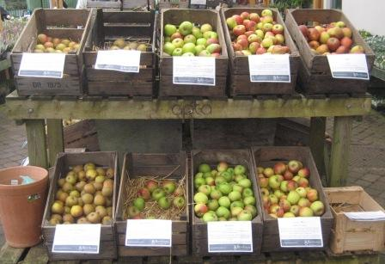An assortment of apple varieties for sale at Beetham Nursery Beetham again stocked a range of 30 different apple and 3 pear varieties for sale. Customers browsed and purchased different varieties, demonstrating that there is clearly an interest in the lesser known varieties of English top fruit.

SEDBERGH APPLE DAY Saturday 26th October
The wet weather did not deter the hardy folk of Sedbergh. COGS (Community Orchard Group Sedbergh) fourth Apple Day again used SLOG’s Spiedel Mill & Hydropress. Locals queued up in the People’s Hall car park to keep the press running from 10am to 2pm. Inside the hall there was a range of stands and live musical accompaniment where Hilary & Andy carried out apple identification and gave technical advice. Most apples were very local, quite a number being seedlings, but one was from a tree grown from a pip brought all the way from Kashmir!

MEMBERS APPLE PRESSING DAY Sunday 3rd November, Burneside
Romola & Edward hosted the fourth version of our late season members pressing which seems to grow in popularity each year. This year we had a busy morning with both presses working hard, but a quieter afternoon. Some of the apples were huge, especially a batch of Lord Derby which jammed the Voran Mill and had to be cut before being milled. The weather was damp and drizzly, necessitating cardboard laid over the grass to protect it. Many thanks to Romola & Edward for their hospitality, hot drinks, flapjack and a very pleasant ambience in the delightful location of Sprint Mill.

SLOG ORCHARD UPDATE
This year gave us our best pear crop yet. There was no frost and the good weather at blossom ensured a good fruit set. The apples were a bit more variable – it seemed that some varieties, after two successive good years were taking a rest so our overall crop was down on last year. This was particularly the case with the Cumbrian variety row, but that might be because they were not summer pruned last year in order to provide plenty of scion wood for grafting workshops. Our second summer working party on 17th August summer pruned all the trees, thinned (belatedly) some of the apples and put some more canes in and tied in new growth. Thanks to George, Tim, Hugh, Romola, Adam, & Paul for getting all this done. The grass in the alleys was mowed six times this year; the cut grass has been composted along with the weeds so we should again have some good compost to mulch the trees early next year.
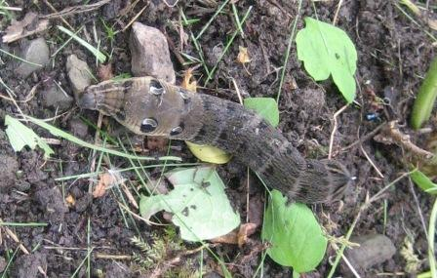Elephant hawk moth larva (head on left) displaying “snake eyes” to deter predators, found by Hugh whilst weeding
Our next working party is scheduled from 10am on Saturday 16th November to remove two false varieties and one dying tree and replace them with others, also to fix some trees in danger of collapsing under the weight of crop with broken canes, check ties and generally tidy up.

Frequently Asked Questions
Our rootstock supplier, F.P.Matthews, recently issued a set of frequently asked questions (and answers) around the subject of tree planting and early years’ maintenance. It is reproduced here courtesy of F.P.Matthews because now is the best time to plant trees, so this information is particularly topical and useful.

Why use rootstocks?
- They provide a known vigour which creates more uniform tree production.
- Rootstocks are selected to encourage trees to produce more fruit rather than vegetative growth, dwarfing trees produce fruit earlier.
- They provide disease resistance to problems such as woolly aphid.
- Some provide better anchorage and cope better with poor soils or wet soils.
- To reproduce a fruit variety, wood from the mother tree has to be budded or grafted onto a rootstock, planting pips or stones has unpredictable results.
- Some rootstocks can ‘sucker’ i.e. send out shoots, these need to be ripped downwards to prevent them returning rather than cut.
How long until it fruits?
- Apples start within one or two years especially on dwarf rootstocks.
- Gages and pears can take several years and more patience is needed.
- Other fruits can vary seasonally. Often they can be biennial.
- Thinning fruit can be beneficial when there are heavy crops. Plum Victoria will often over produce and branches may break.
- Good warm weather during blossom will always help fruit set.
- Stress on established trees helps to produce more fruit bud for the following year.
Do I need a pollinator?
- Although self-fertility is a good selling point, gardeners should relax about this issue. Bees travel long distances!
- Self-fertile varieties can produce the heaviest crops but often the smallest individual fruit.
- Solitary bee species (not honey bees) will pollinate more fruit trees.
- Spraying water on flowers with a hose will increase pollination for early flowering types when there are limited insects (peaches etc)
When should I prune my trees and how?
- Have courage – trees are very resilient!
- Good secateurs and a small folding saw are a good investment.
- Young trees need to be pruned to shape the tree in the first few years especially after planting to reduce the stress of the tree when its energy is needed for new root production.
- Encourage and leave the naturally wide angle branched at the expense of the narrow angled branches that will split out in later years.
- Pruning helps create an airy tree canopy which reduces both diseases and pests.
- Pruning increases fruit eating quality and storage as sunlight encourages natural sugars and attractive colouring of the skin
- Pruning encourages young replacement branches which creates healthy new growth and prolongs the life of the tree
- Apples and pear can be pruned any time of year, stoned fruit such as plums and cherries are best pruned late summer. A good time to prune is after flowering when one can see the fruit.
- Pruning can have equal influence on tree size than just relying on rootstock influence.
- Trained trees (espalier and step overs in particular) need to have any vertical growth spur pruned back regularly. Pinching of growing tips with finger nails whilst watering and weeding saves time.
- In the first two years make sure the bottom tiers are well formed and established before allowing the tree to increase in height too quickly. One tier a year is the limit.
- Established trained should be spur pruned mid-June – not before. Also hard back to 1-2 buds on all extension growth. This will set fruit bud for the following year.
- Festooning (tying down branches to achieve an umbrella shaped tree canopy) will encourage fruit bud development and combat strong vegetative growth: tied down or horizontal branches set fruit bud better. Fruit weight will do the rest.
Can I grow my tree in a pot and for how long?
- Need to be fed and watered well.
- Growing trees in pots will negate strong rootstock influence and there is danger that dwarf rootstocks will underperform, small fruit, stress, more pest and disease.
- Every other year remove the tree from pot in winter, root prune mid-winter, add fresh compost around the edge or increase pot size. Feed and water in well.
What can I plant on a north facing wall or shady spot?
- Cherry Morello is the past stock answer but is now not so popular.
- Modern apple varieties that are early to mid-season picking are ideal.
- There tends to be less blossom damage by frost because thawing fruit buds do not rupture so easily at sun rise.
What is a heritage variety?
- Heritage varieties are pre 1900 – dates of varieties are given in our catalogue.
- Some good varieties continue to be grown: Apple Bramley, Apple Ashmead’s Kernel, Pear Conference, Plum Victoria, many old varieties are less popular for a reason, new varieties are often more productive and disease resistant. [Ed: not true for canker]
Can I grow fruit trees on acid or alkaline soils?
- All fruit performs well on mildly acid to mildly alkaline soils.
- Very acid soils increase canker.
- Very alkaline soils will lock up some minerals and more deficiencies can be seen in leaf symptoms i.e. magnesium.
Do trees need fertilising?
- When planted a sachet of FPM rootgrow will help the tree establish. This product is especially formulated with Mycorrhiza fungi which encourages quick establishment of the trees roots.
- Trees are generally pretty tough and will cope well with most soil types so no fertiliser is needed once the tree is established.
- It is important to water trees well in their first summer, a good watering can twice a week.

PLAGUES & PESTILENCE: Damson Bent Banana Disease
Bent banana disease (Taphrina pruni) has been reported several times on damsons this season and the following article on the subject by Peter Cartmell is reproduced from the Westmorland Damson Association website. This disease has been on the increase in Westmorland damson orchards over recent years, moving up from the south. It is commonly known as "Pocket Plum" and was first identified in Italy in 1583. The nearest recent large scale outbreak was in Worcestershire in 1988.
The cause is a fungus - Taphrina pruni - and its spread is favoured by higher than average rainfall and warmth in early Spring. Spread of the fungus is by ascospores which are released from infected fruit.
These spores carry the infection and the fungus then remains on the bark, in bud scales and even beneath the tree during the following Winter. The next Spring, if conditions are right, the fungus attacks the young fruitlets.
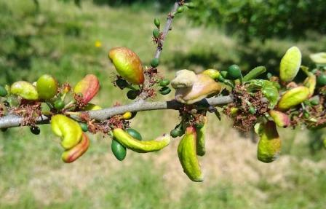 ^{photo: Dick Palmer} The first signs of infection are the appearance of small whitish spots on the fruitlets three to four weeks after blossom time. These spots enlarge rapidly as the fruit develops.
The flesh of the young fruit then becomes spongy. No damson stone is formed, a cavity develops and the infected fruit grows much more quickly than the healthy fruit.
The diseased damson becomes grotesque, curved and yellowed resembling a small bent banana. Before the infected fruit eventually falls it turns grey and creased resembling the opening in a saggy jacket pocket, hence the name "Pocket Plum" Some remain on the tree.
The disease carries over from one season to another and burning of all infected fruit and twigs with removal of any decaying matter on the ground beneath the tree is the only certain cure.
Damson growers will know that this is well nigh impossible. Spraying with Bordeaux mixture in the Spring is rarely effective.
Organic gardeners could try spraying with a solution made up from Mare's Tail weed (Equisetum arvense). It has had some success in controlling apple scab.
The whole of a tree's crop is rarely infected and healthy fruit may be found alongside and touching infected ones.
The appearance of the trees in the Spring when the fruit is starting to fill out and when grotesque ones seem to be everywhere, is rather discouraging and one tends to panic.
Like several other arboricultural operations on damson trees, things are possibly better left to look after themselves. The view of some people is that the disease is a natural thinning operation and the remaining damsons are all the better for it.

© Westmorland Damson Association 1998

for further information see also the RHS website: https://www.rhs.org.uk/advice/profile?pid=199
NEW APPLE VARIETY: EDEN

Our rootstock supplier Frank Matthews recently introduced a new apple variety called Eden. 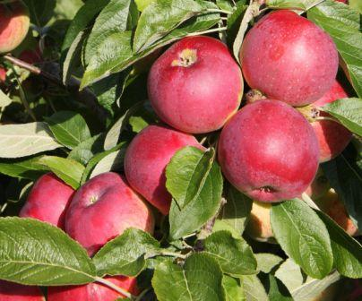 Image: Frank Matthews It is described as a non-browning apple for fresh eating and cooking, delicious, crisp, sweet and aromatic. It behaves like Bramley when cooked, producing a snow white puree requiring no added sugar. Eden was bred in Canada in 1971 and is the first variety whose flesh does not oxidise (go brown) when cut. This is a particularly useful characteristic for use in salads and processing.
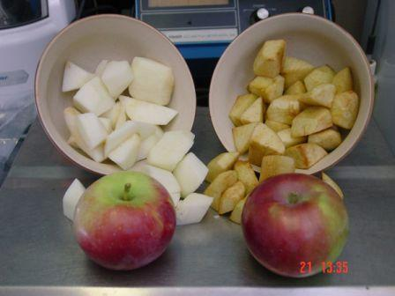 Left: Eden, right: MacSpur The Canadian researcher Dr. Shahrokh Khanizadeh was trying to pinpoint traits that would make it easier–and faster–to select apples that would be resistant to disease. A colleague suggested he examine antioxidant levels as a possible indicator.
“Most of the scab-resistant apples—almost 95 percent of them—have a specific antioxidant,” said Khanizadeh, a research scientist with Agriculture and Agri-Food Canada in St. Jean-sur-Richelieu, Quebec.
Phenolic compounds—antioxidants that lend aromatic qualities to fruit but can also be toxic to some fungi—became a focus of his research.
Meanwhile, Khanizadeh was trying to identify new apple varieties for Quebec’s juice and cider producers. The two research projects began to blend, and one day he noticed one apple that wasn’t browning as quickly as the other samples. At first, he thought it had been prepared later than the others.
“We were using those advanced lines that we had already selected for juice or for cider apples,” he said. “All of a sudden, we realized that one of these apple varieties that we were working on and that we were hoping to use for cider wasn’t turning brown.”
Further research into phenolic levels linked the resistance to browning to the low level of phenols in the flesh of the apple, which has approximately two-fifths of the phenolic compounds found in Spartan.
Recently trademarked with the name Eden, the new variety is the product of a cross originally made in 1971 of Linda, a Langford Beauty cross, and Jonamac.
The skin is dark red over greenish yellow, and the flesh is pure white. The flesh of the fresh-picked fruit remains white up to two days after cutting, making it appealing to processors who see its potential for apple chips, fresh-cut slices, and pie filling, where appearance is important. Natural resistance to oxidation would eliminate the need for citric acid that accounts for up to 60 percent of the cost of processing apple slices for the fresh-cut and pie markets.
with acknowledgement to “Good Fruit Grower”

WILLOW MULCHING
Many trees contain powerful pharmaceutical compounds which have the potential to manage a range of plant diseases. Willow has relatively high levels of salicylic acid, the active ingredient in ‘Aspirin’. Previous research has indicated that application of single species willow woodchip can help manage scab in apple and other top fruit crops. A new field study aims to validate these findings on commercial orchards in the UK, using a number of different willow species, and carry out a cost benefit analysis of this approach to scab management. If the results are promising, the project will be expanded in subsequent years to look at whether and to what extent the addition of biochar enhances the efficacy, and whether the timing of application of the mulch has any effect. The willow mulch is recommended to be applied 5-10cm deep over the area beneath the tree’s canopy according to Dr G Percival of the Bartlett Tree Research Lab., Charlotte, North Carolina, USA. Application should be made in January/February because the salicylic acid takes 4-6 weeks to leach into the soil and for root uptake to take effect at bud burst and exert a protectant effect against the earliest scab infection periods. He claims that leaves of mulched trees become thicker and more lignified, and contain more resins and phenolics. Because multiple defence mechanisms are stimulated, he postulates that it is unlikely that scab can develop resistance to this treatment. Analysis at Reading University showed a wide difference in salicylic acid content between a range of willow species sampled from the Royal Botanic Gardens at Kew: Salicylic Acid (mg/g FW)
S. caprea 1.95 (goat or pussy willow)
S. alba 0.20 (white willow)
S. daphnoides 3.21 (violet willow)
S. alba ‘Chermesina’ 1.62 (scarlet willow)
S. erythrotoflexuosa 0.38 (tortuosa)
S. fragilis 1.65 (crack willow)
S. triandra 0.60 (almond-leaved willow)
S. viminalis 0.21 (common osier)
S. matsudana tortuosa 2.33 (pekin willow)
S. pentandra 0.81 (bay willow)
So – choose your willow species for maximum effect. Funding has been approved for “Innovative Farmers” to run phase two studies during 2019. courtesy of: https://www.innovativefarmers.org/news/
SCION WOOD ORDERS
Scion wood from a multitude of varieties of apples and pears will be available at our grafting workshop next year. However if there is a particular variety you want, it can be ordered from Brogdale. SLOG will consolidate all such requests (£5 per variety) into a single order to save on carriage & handling charges. Send your orders to Hilary at overmoor@btinternet.com by December 31st for delivery in February 2020 for our grafting workshop.
GRAFTING TO ORDER
The SLOG grafting to order service is again available this winter. If you want a particular variety on a particular rootstock, it can, subject to availability, be grafted for you. Price is £15 per tree, buyer collects. Call Andy Gilchrist on 01539 727772 for enquiries & orders.
SLOG SHOP
1. SLOG has a range of mostly 1yr old container grown maiden apple trees for sale at £13.50 each, comprising traditional varieties suitable for our Northern climate on MM106 & MM111 rootstocks. Visit http://www.slorchards.co.uk/TreesForSale.html to see the list and for guidance on purchase and collection. 2. Wells & Winter labels are the most cost-effective permanent solution for recording tree variety identity. They are rigid black plastic labels measuring 2 x 3½” (5x9cm), giving a permanent and very visible result.
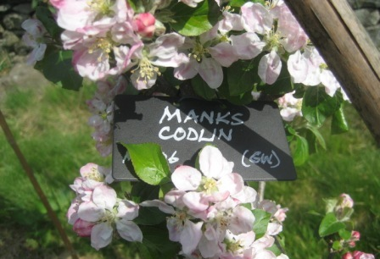They are available at 15p each along with a deposit for the silver pen (if taken away)

3. Apple Notelet cards £2 per pack of 5 different cards each featuring a different apple variety. 4. Recipe books: 28 full colour pages detailing 45 recipes for a wide range of fruits only £2.50.

5. The Apples & Orchards of Cumbria: Lavishly illustrated with over 100 full colour photos describing the twenty or so Cumbrian apple varieties and the fifteen orchards open to the public. Judged runner-up in the “Landscape & Tradition” category of the Lakeland Book of the Year Awards, 2014. £9
All the above items are available at SLOG events such as Shows, Apple Days and the Winter Meeting.
SLOG Discount at Suppliers: Rogers & Beetham Nursery
SLOG has negotiated a 10% discount at Rogers of Pickering for SLOG members. When you place an order for any kind of fruit: trees, bushes, etc., quote your SLOG membership number and Rogers will apply 10% discount to your purchases. For mail orders go to: http://www.rvroger.co.uk/?linksource=frontpage
We also have a 5% discount at Beetham Nursery applicable to all items (except in the café). Just show your SLOG membership card at the checkout. www.beethamnurseries.co.uk/
TAILPIECE
“The Apple of Your Eye” is a quarterly publication, the next one being the spring issue due mid-February. Contributing articles, preferably in word.doc, are welcome, along with photos where possible, by the end of January 2020 to: newsletter@slorchards.co.uk

Disclaimer - The information in this newsletter is provided on the understanding that SLOG makes no warranties, either expressed or implied, concerning the accuracy, completeness, reliability, or suitability of the information. Nor does SLOG warrant that the use of this information is free of any claims of copyright infringement.

The opinions expressed in this publication do not
neccessarily represent the views of SLOG.
© 2019 South Lakeland Orchard Group

